

*Issue No: 23 7 Date: Friday 28th March 2025*

*Our Newsletter comes out every Friday with updates about what the children have been up to during the week, information, things to celebrate and important dates for the diary. Please take the time to read through and if you have any questions, please speak to Mrs Taylor in the office.*

**This Week’s Achievements**

**Willows Star of the Week**

**Sycamores Star of the Week**

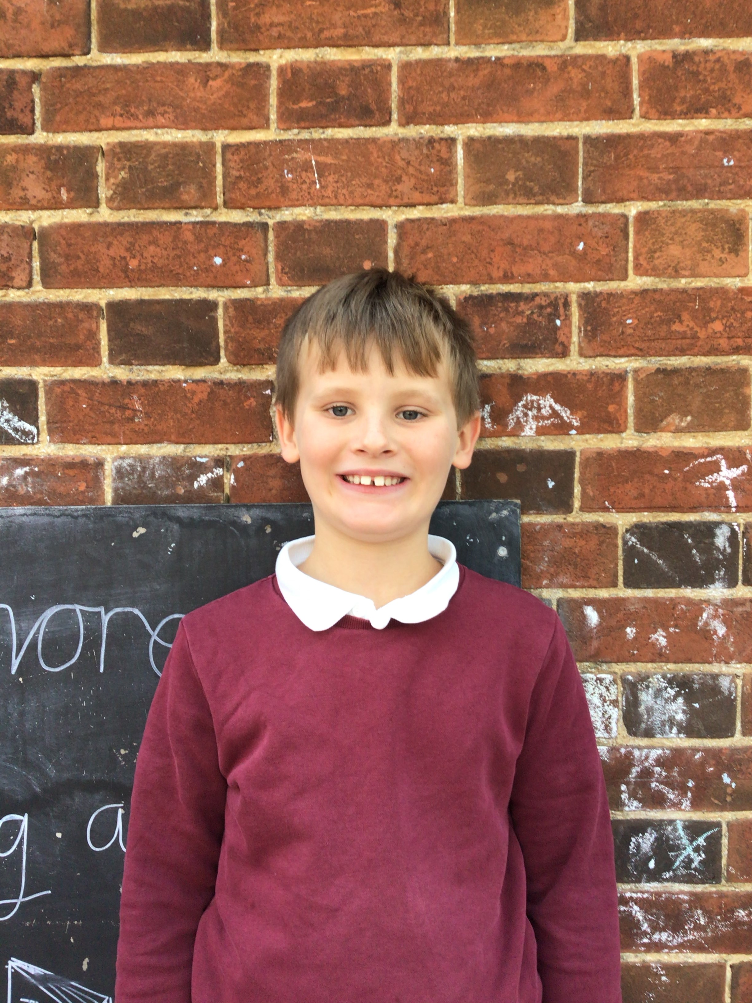

Millie for showing perseverance in reading and great determination in Forest school.

For showing an increased confidence in the performance rehearsals this week.

For settling into our Willows class so well and always contributing in class.

**Class Attendance**

Willows – 90.42%

Sycamores – 92.16%

Oaks – 89.35%

CHALLENGE

NURTURE

INSPIRE

CHALLENGE

NURTURE

INSPIRE

**Oaks Star of the Week**

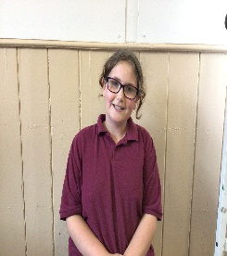

**House Points for this week**

Stephen Hawkings – 371

Beatrix Potter – 272

Benjamin Britten – 292

Kelly Holmes – 346

For a great effort and focus this week especially in Math’s and Grammar.



No Numbots stages completed this week!



Willows: 1st Phoebe

2nd Joel

3rd Arlo

Sycamores: 1st Evie

2nd Ned

3rd Molly

Oaks: 1st Charlie T

2nd Jesse-James

3rd Sienna



Charlie – Unsigned Act

Joel & Alannah – Support Act

Phoebe – Rock star

Evie – Rock Legend



**Sycamores Samba**

**Don’t Forget** - Sycamores have their final Samba lesson on Tuesday 25th of March. The children would love to show their new Samba skills to their parents/carers. So we would like to invite you in to watch their final performance at 11am.

Can’t make it? Don’t worry, we will record the performance and post this on class Dojo.

**Reminders for Next Term:**

**Oaks Class** – PE Mondays & Tuesdays

**Sycamores Class** – PE Wednesdays & Thursdays

**Willows Class** – PE Tuesdays & Fridays

**Fridays Forest School lessons**– Year 2’s & Oaks class

**Monday – Friday** (3.15pm until 4.30pm/5pm) Little Legends after-school club

**Monday – Friday** (8am until 8.40am) Breakfast Club

**Mondays** – Year 6 SATs Club (3.15pm until 4.15pm)

**Mondays** – Years 3 – 4’s Art Club (3.15pm until 4.15pm)

**Mondays** – Green Finger Gardening club (3.15pm until 4.15pm)

**Tuesdays** – Years 5 – 6’s Art Club (3.15pm until 4.15pm)

**Wednesdays** – Funky Feet Street Dance Club (3.15pm until 4.15pm)

**Fridays** – Forest School club (3.15pm until 4.15pm)

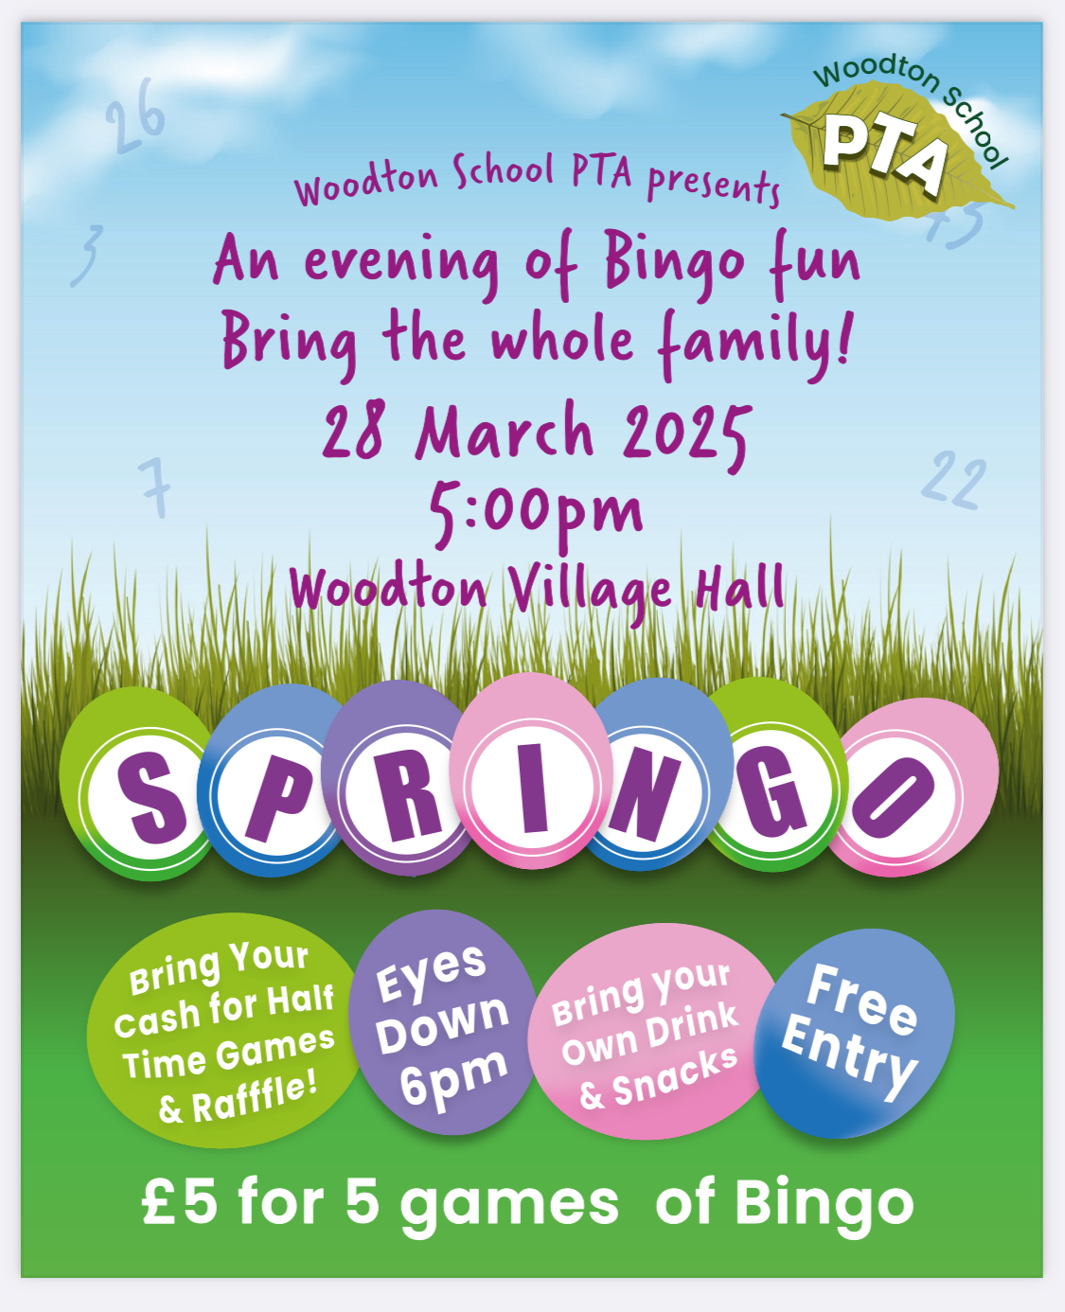

**Comic Relief Day**

**Thank you to everyone that took part in the ‘Wear Something Red’ non-uniform day. If you haven’t donated yet, the fundraising page is still open.**

[**https://www.justgiving.com/fundraising/rnd25-ellingham-vc-primary-school**](https://www.justgiving.com/fundraising/rnd25-ellingham-vc-primary-school)



**Dates for the Diary**

**Monday 24th March** – Year 4 Cycling Proficiency & Seatbelt lesson

**Tuesday 25th March** – Sycamores Samba Performance to parents

**Wednesday 26th March** – PTA Non-Uniform Day in exchange for a Easter Egg or gift

**Friday 28th March** – PTA Springo Event

**Tuesday 1st April** – Sycamores Performance 6 pm

**Monday 7th Apr – Wed 23rd Apr** – Easter Break

**Monday 5th May** – Bank Holiday Monday

**Wednesday 7th May** – Willows Multi-Skills Event – Hobart High School

**Thursday 8th May** – Sycamores Rugby Skills Event – Wymondham Rugby Club

**Mon 12th – Fri 16th May** – Year 6 SATs week

**Mon 26th May – Fri 30th May** – Half Term

**Monday 9th June** – Selected Oaks Rounders Event – Hobart High school

**Tuesday 10th June** – Tempest Photos – Class & Year 6 Leavers

**Wednesday 18th June** – Oaks Athletics Event – UEA, Norwich

**Monday 23rd June** – Selected children for Tri-Golf – Bungay Golf Club

Website – <http://www.ellinghamandwoodton.co.uk/>

**PTA Non-Uniform Day**

**Wednesday 26th March**

The PTA are holding a non-uniform day, in exchange for a Easter Egg or Easter Gift for their Springo event that is being held at Woodton Village Hall on Friday the 28th of March (6pm). Please bring all contributions into the school office at morning drop off.



**Headlice Alert!**

We have had reports of head lice. Please may we ask that children are checked over the weekend and treated if needed. Thank you





There are lots of books we would like to purchase for our school library and class book corners. So, we are launching an Amazon wish list, in the hope that our lovely parents and carers may be able to purchase some for us! All of the books are on recommended book lists, with a mixture of fiction and non-fiction. Many of the books are also dyslexia friendly. The link for the wish list is <https://www.amazon.co.uk/hz/wishlist/ls/1PIYX7KS6DKSV?ref_=wl_share>

Thank you very much!