

*Issue No: 24 7 Date: Friday 4th April 2025*

*Our Newsletter comes out every Friday with updates about what the children have been up to during the week, information, things to celebrate and important dates for the diary. Please take the time to read through and if you have any questions, please speak to Mrs Taylor in the office.*

**This Week’s Achievements**

**Willows Star of the Week**

**Sycamores Star of the Week**

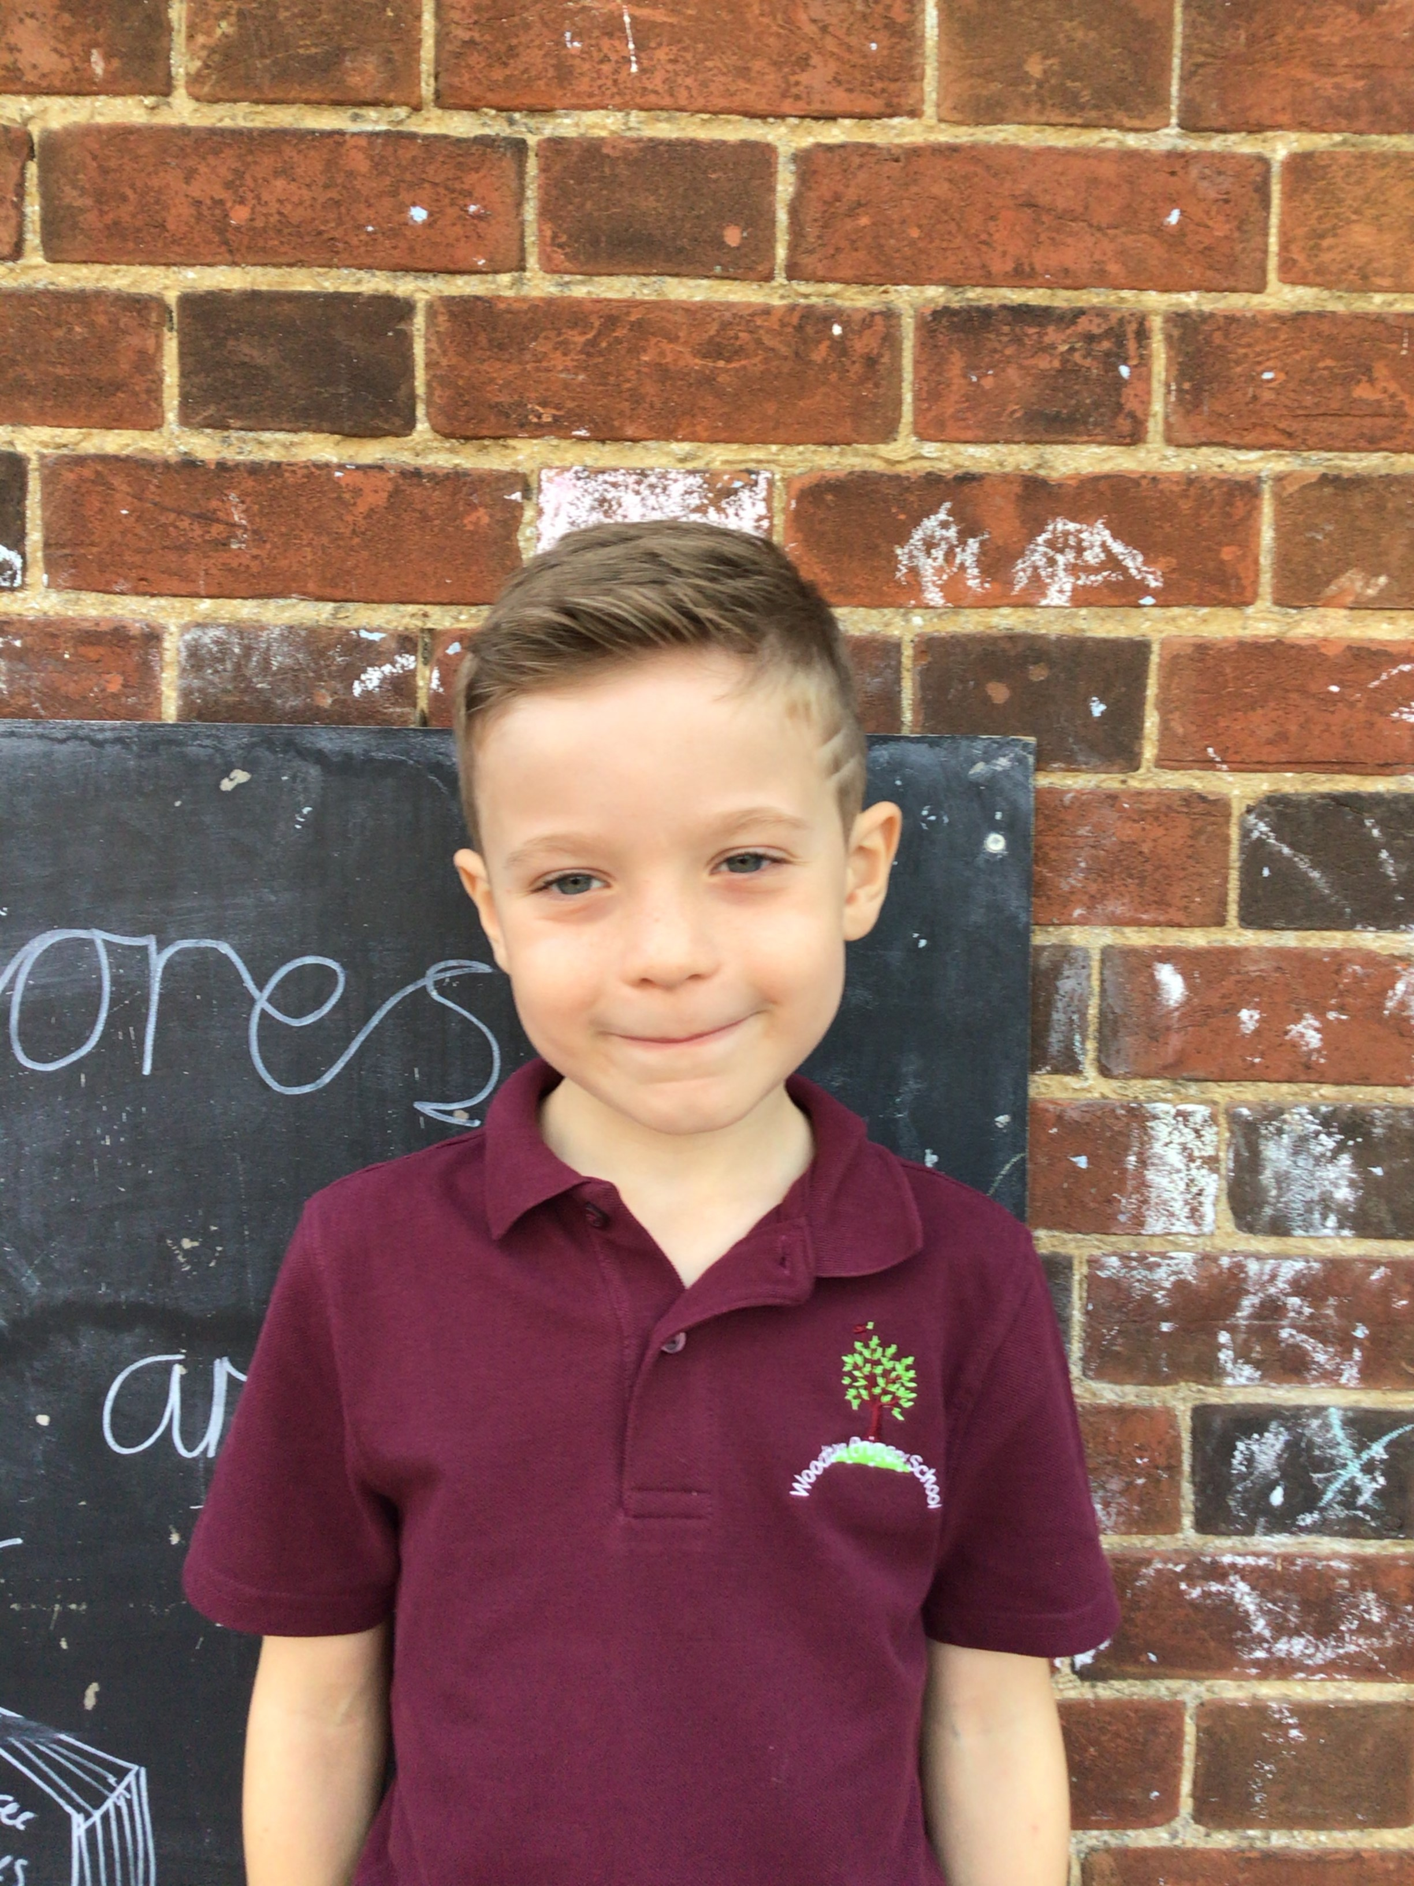

Millie for showing perseverance in reading and great determination in Forest school.

For engaging positively and asking lots of questions on our visit to the Bronze Ring Ditch.

For putting full effort into all of his work this week.

**Class Attendance**

Willows – 92.98%

Sycamores – 92.65%

Oaks – 96.57%

CHALLENGE

NURTURE

INSPIRE

CHALLENGE

NURTURE

INSPIRE

**Oaks Star of the Week**

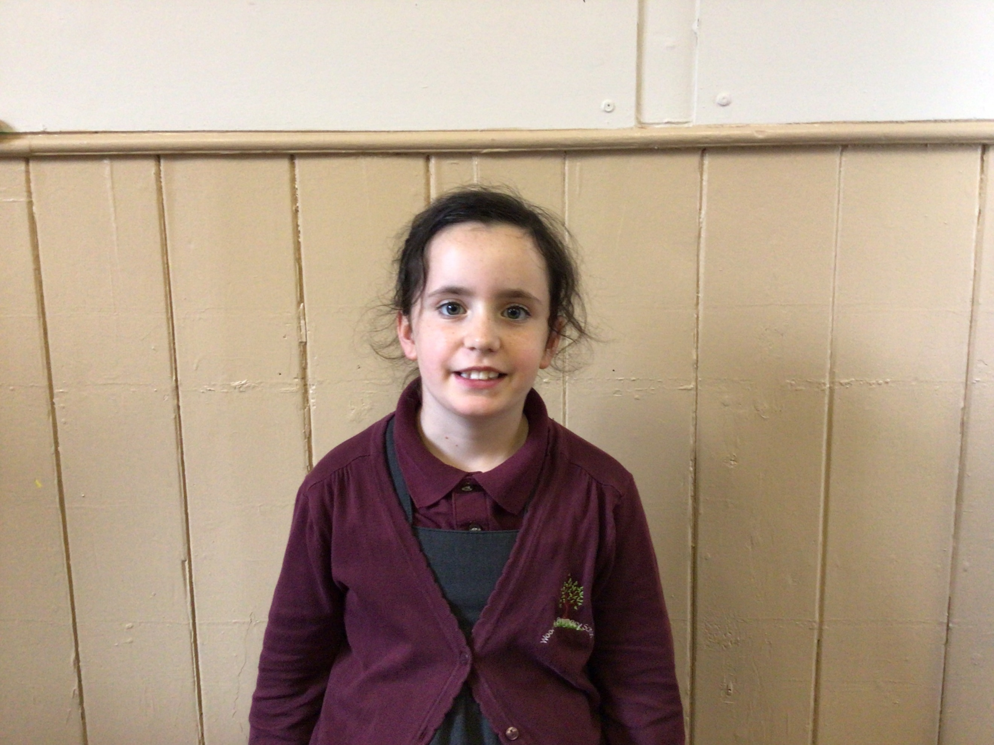

**House Points for this week**

Stephen Hawkings – 237

Beatrix Potter – 158

Benjamin Britten – 152

Kelly Holmes – 233

For always being a great role model to everyone with her kindness and her fantastic attitude in class.



No Numbots stages completed this week!



Willows: 1st Jude

2nd Joel

3rd Maci

Sycamores: 1st Finlay

2nd Charlie Wi

3rd Molly

Oaks: 1st Sienna

2nd Isla

3rd Flo



Sienna – Rock Legend

Charlie Wi – Breakthrough Artist



**Reminders for Next Term:**

**Oaks Class** – PE Mondays & Tuesdays

**Sycamores Class** – PE Wednesdays & Thursdays

**Willows Class** – PE Tuesdays & Fridays

**Fridays Forest School lessons**– Reception & yr 1’s and Sycamores

**Monday – Friday** (3.15pm until 4.30pm/5pm) Little Legends after-school club

**Monday – Friday** (8am until 8.40am) Breakfast Club

**Mondays** – Football Club (3.15pm until 4.15pm)

**Mondays** – Green Finger Gardening club (3.15pm until 4.15pm)

**Tuesdays** – Years 3, 4, 5 & 6’s Art Club (3.15pm until 4.15pm)

**Wednesdays** – Year 6 SATs Club (3.15pm until 4.15pm)

**Wednesdays** – Funky Feet Street Dance Club (3.15pm until 4.15pm)

**Fridays** – Forest School club (3.15pm until 4.15pm)



There are lots of books we would like to purchase for our school library and class book corners. So, we are launching an Amazon wish list, in the hope that our lovely parents and carers may be able to purchase some for us! All of the books are on recommended book lists, with a mixture of fiction and non-fiction. Many of the books are also dyslexia friendly. The link for the wish list is <https://www.amazon.co.uk/hz/wishlist/ls/1PIYX7KS6DKSV?ref_=wl_share>

Thank you very much!

**Dates for the Diary**

**Monday 7th Apr – Wed 23rd Apr** – Easter Break

**Monday 5th May** – Bank Holiday Monday

**Wednesday 7th May** – Willows Multi-Skills Event – Hobart High School

**Thursday 8th May** – Sycamores Rugby Skills Event – Wymondham Rugby Club

**Mon 12th – Fri 16th May** – Year 6 SATs week

**Friday 16th May** – Year 6 SATs Treat

**Mon 26th May – Fri 30th May** – Half Term

**Monday 9th June** – Selected Oaks Rounders Event – Hobart High school

**Tuesday 10th June** – Tempest Photos – Class & Year 6 Leavers

**Wednesday 18th June** – Oaks Athletics Event – UEA, Norwich

**Monday 23rd June** – Selected children for Tri-Golf – Bungay Golf Club

Website – <http://www.ellinghamandwoodton.co.uk/>

**Sycamores Performance**

**A BIG well done to our Sycamores class for an amazing performance of ‘The Boy, the Mole, the Fox and the Horse’.**