

*Issue No: 21 7 Date: Friday 14th March 2025*

*Our Newsletter comes out every Friday with updates about what the children have been up to during the week, information, things to celebrate and important dates for the diary. Please take the time to read through and if you have any questions, please speak to Mrs Taylor in the office.*

**This Week’s Achievements**

**Willows Star of the Week**

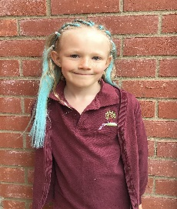

**Sycamores Star of the Week**

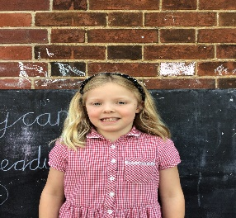

Millie for showing perseverance in reading and great determination in Forest school.

For working with great determination in Math’s when having to multiply digits with an exchange.

For being kind to her friends and always contributing in class.

**Class Attendance**

Willows – 94.74%

Sycamores – 98.04%

Oaks – 93.52%

CHALLENGE

NURTURE

INSPIRE

CHALLENGE

NURTURE

INSPIRE

**Oaks Star of the Week**

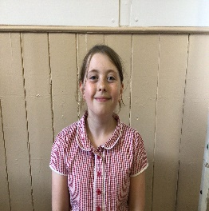

**House Points for this week**

Stephen Hawkings – 222

Beatrix Potter – 209

Benjamin Britten – 312

Kelly Holmes – 284

For a lovely story in English and a great effort in her grammar work.



Congratulations to Alfie for completing the Steel stage in NumBots this week.



Willows: 1st Arlo

2nd Jack

3rd Joel

Sycamores: 1st Ned

2nd Finlay

3rd Maisy

Oaks: 1st Charlie T

2nd Alana

3rd Sienna



Aria – Headliner

Maisy – Rock Legend



**Sycamores Samba**

Reminder - Sycamores have their final Samba lesson on Tuesday 25th of March. The children would love to show their new Samba skills to their parents/carers. So we would like to invite you in to watch their final performance at 11am.

Can’t make it? Don’t worry, we will record the performance and post this on class Dojo.

**Reminders for Next Term:**

**Oaks Class** – PE Mondays & Tuesdays

**Sycamores Class** – PE Wednesdays & Thursdays

**Willows Class** – PE Tuesdays & Fridays

**Fridays Forest School lessons**– Year 2’s & Oaks class

**Monday – Friday** (3.15pm until 4.30pm/5pm) Little Legends after-school club

**Monday – Friday** (8am until 8.40am) Breakfast Club

**Mondays** – Year 6 SATs Club (3.15pm until 4.15pm)

**Mondays** – Years 3 – 4’s Art Club (3.15pm until 4.15pm)

**Mondays** – Green Finger Gardening club (3.15pm until 4.15pm)

**Tuesdays** – Years 5 – 6’s Art Club (3.15pm until 4.15pm)

**Wednesdays** – Funky Feet Street Dance Club (3.15pm until 4.15pm)

**Fridays** – Forest School club (3.15pm until 4.15pm)

**Comic Relief Day**

**Friday 21st March**

Everyone is invited to come to school in non-uniform wearing something **RED** for a small donation to show their support. We have set up a Federation justgiving page to make it easy to contribute

[**https://www.justgiving.com/fundraising/rnd25-ellingham-vc-primary-school**](https://www.justgiving.com/fundraising/rnd25-ellingham-vc-primary-school)



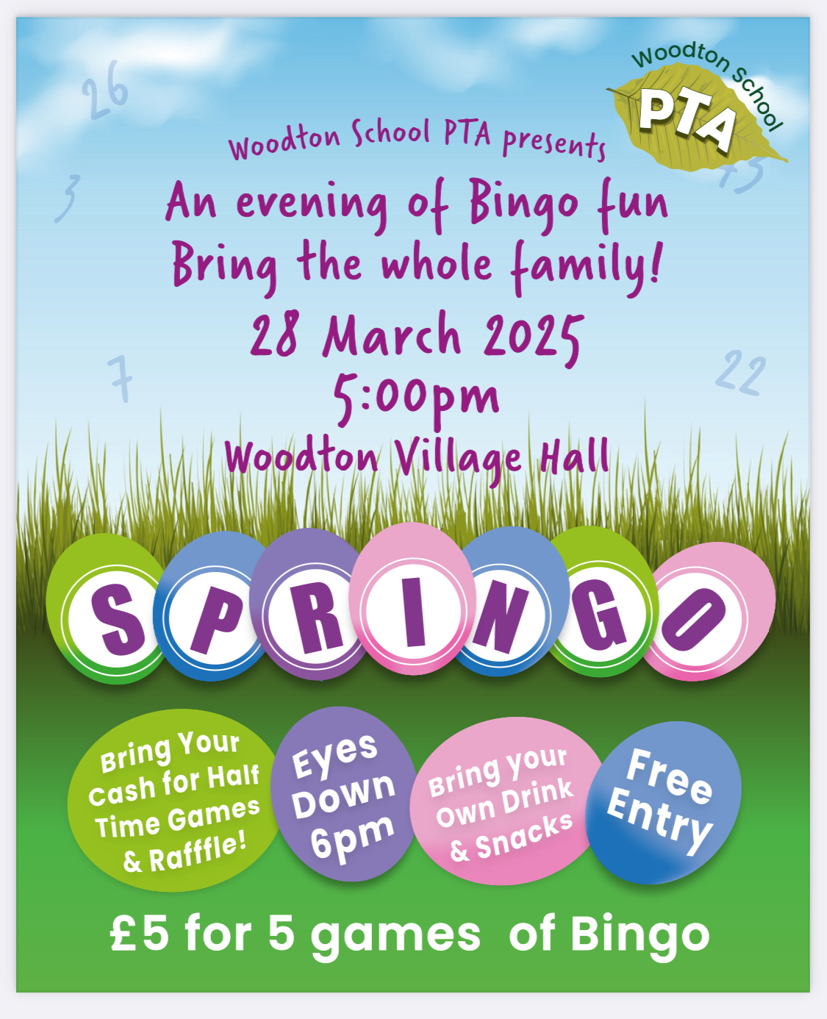

**Dates for the Diary**

**Monday 17th March** – Year 4 Cycling Proficiency

**Thursday 13th March** – Parents Evening

**Friday 21st March** – Non-Uniform Day wearing something Red for Comic Relief

**Monday 24th March** – Year 4 Cycling Proficiency & Seatbelt lesson

**Tuesday 25th March** – Sycamores Samba Performance to parents

**Wednesday 26th March** – PTA Non-Uniform Day in exchange for a Easter Egg or gift

**Friday 28th March** – PTA Springo Event

**Tuesday 1st April** – Sycamores Performance 6 pm

**Monday 7th Apr – Wed 23rd Apr** – Easter Break

**Monday 5th May** – Bank Holiday Monday

**Wednesday 7th May** – Willows Multi-Skills Event – Hobart High School

**Thursday 8th May** – Sycamores Rugby Skills Event – Wymondham Rugby Club

**Mon 12th – Fri 16th May** – Year 6 SATs week

**Mon 26th May – Fri 30th May** – Half Term

**Monday 9th June** – Selected Oaks Rounders Event – Hobart High school

**Tuesday 10th June** – Tempest Photos – Class & Year 6 Leavers

**Wednesday 18th June** – Oaks Athletics Event – UEA, Norwich

**Monday 23rd June** – Selected children for Tri-Golf – Bungay Golf Club

Website – <http://www.ellinghamandwoodton.co.uk/>

**PTA Non-Uniform Day**

**Wednesday 26th March**

The PTA are holding a non-uniform day, in exchange for a Easter Egg or Easter Gift for their Springo event that is being held at Woodton Village Hall on Friday the 28th of March (6pm). Please bring all contributions into the school office at morning drop off.



**Science Week Open Afternoon**

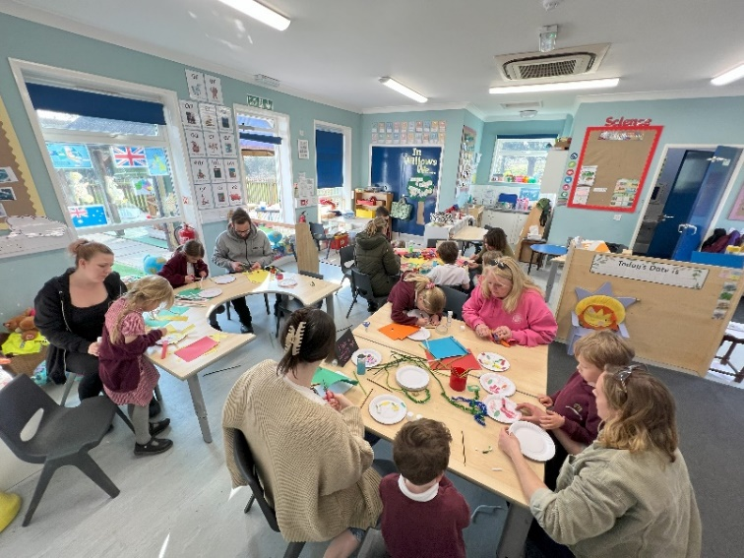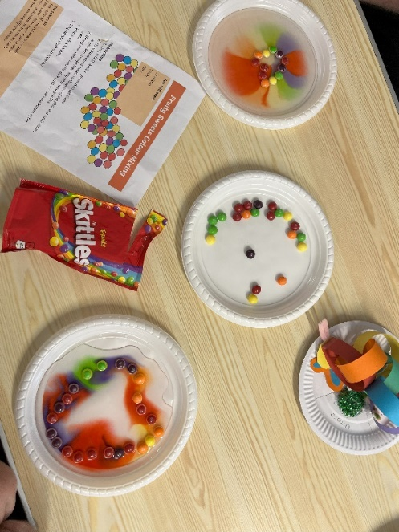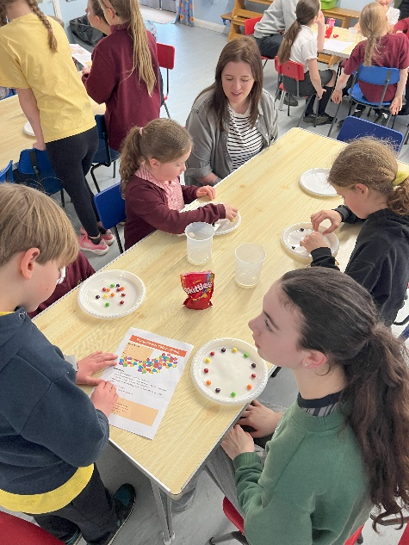Thank you to everyone that came and joined in with the Science week open afternoon on Monday. Each classroom had different activities, we made star constellations tube projectors, created different sounds with glass bottles filled with water, made rainbows with skittles and water, caterpillar paper chains and much much more…