

*Issue No: 20 7 Date: Friday 7th March 2025*

*Our Newsletter comes out every Friday with updates about what the children have been up to during the week, information, things to celebrate and important dates for the diary. Please take the time to read through and if you have any questions, please speak to Mrs Taylor in the office.*

**This Week’s Achievements**

**Willows Star of the Week**

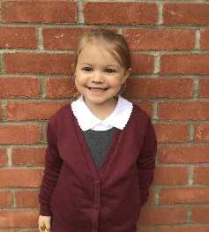

**Sycamores Star of the Week**

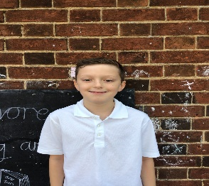

Millie for showing perseverance in reading and great determination in Forest school.

For demonstrating great resilience in Art this week.

For being an amazing role model for everyone in the school and always giving everything her best.

**Class Attendance**

Willows – 94.71%

Sycamores – 96.57%

Oaks – 92.59%

CHALLENGE

NURTURE

INSPIRE

CHALLENGE

NURTURE

INSPIRE

**Oaks Star of the Week**

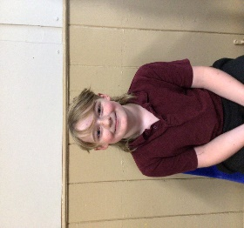

**House Points for this week**

Stephen Hawkings – 261

Beatrix Potter – 187

Benjamin Britten – 305

Kelly Holmes – 232

For great determination with his Maths work this week.



Willows: 1st Arlo

2nd Phoebe

Sycamores: 1st Molly

2nd Evie

3rd Maisy

Oaks: 1st Charlie T

2nd Jesse

3rd Olivia



Phoebe – Headliner



No Numbot stages completed this week.



**Sycamores Samba**

Reminder - Sycamores have their final Samba lesson on Tuesday 25th of March. The children would love to show their new Samba skills to their parents/carers. So we would like to invite you in to watch their final performance at 11am.

Can’t make it? Don’t worry, we will record the performance and post this on class Dojo.

**Reminders for Next Term:**

**Oaks Class** – PE Mondays & Tuesdays

**Sycamores Class** – PE Wednesdays & Thursdays

**Willows Class** – PE Tuesdays & Fridays

**Fridays Forest School lessons**– Year 2’s & Oaks class

**Monday – Friday** (3.15pm until 4.30pm/5pm) Little Legends after-school club

**Monday – Friday** (8am until 8.40am) Breakfast Club

**Mondays** – Year 6 SATs Club (3.15pm until 4.15pm)

**Mondays** – Years 3 – 4’s Art Club (3.15pm until 4.15pm)

**Mondays** – Green Finger Gardening club (3.15pm until 4.15pm)

**Tuesdays** – Years 5 – 6’s Art Club (3.15pm until 4.15pm)

**Wednesdays** – Funky Feet Street Dance Club (3.15pm until 4.15pm)

**Fridays** – Forest School club (3.15pm until 4.15pm)

**Science Week 10th – 14th March**

British Science Week

Open Afternoon

Monday 10th March 2pm

Woodton Primary School will be celebrating British Science Week with lots of fun science events for the children all week. Please come and join us on Monday 10th March at 2pm for a science afternoon where you can join in the science activities with your child!

We are looking forward to seeing you there!



**Photo Permission Forms**

Everyone would have received a new photo permissions form this week.

Please check your child’s school bag if you haven’t been passed it.

These must be returned to the school office by Monday the 10th.

**Thank you**

**Dates for the Diary**

**Friday 7th March** – Creative Evening 6pm

**Mon 10th – Fri 14th Mar** – Science Week

**Monday 10th March** – Open Science afternoon from 2pm – All Welcome

**Monday 17th March** – Year 4 Cycling Proficiency

**Thursday 13th March** – Parents Evening

**Monday 24th March** – Year 4 Cycling Proficiency & Seatbelt lesson

**Friday 28th March** – PTA Springo Event (Details to follow)

**Tuesday 1st April** – Sycamores Performance 6 pm

**Monday 7th Apr – Wed 23rd Apr** – Easter Break

**Monday 5th May** – Bank Holiday Monday

**Wednesday 7th May** – Willows Multi-Skills Event – Hobart High School

**Thursday 8th May** – Sycamores Rugby Skills Event – Wymondham Rugby Club

**Mon 12th – Fri 16th May** – Year 6 SATs week

**Mon 26th May – Fri 30th May** – Half Term

**Monday 9th June** – Selected Oaks Rounders Event – Hobart High school

**Tuesday 10th June** – Tempest Photos – Class & Year 6 Leavers

**Wednesday 18th June** – Oaks Athletics Event – UEA, Norwich

**Monday 23rd June** – Selected children for Tri-Golf – Bungay Golf Club

Website – <http://www.ellinghamandwoodton.co.uk/>

**World Book Day 2025**

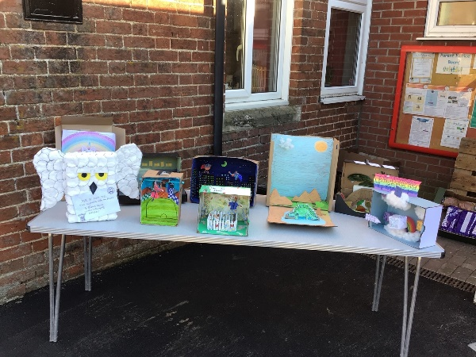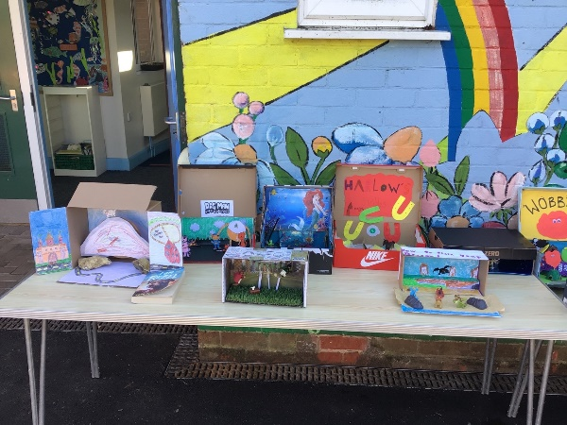This year for world book day, we invited all the children to create a ‘Book in a Box’. We had some amazing creations. The children took part in a variety of different activities during the day, including a whole school shared reading session.

