

*Issue No: 19 7 Date: Friday 28th February 2025*

*Our Newsletter comes out every Friday with updates about what the children have been up to during the week, information, things to celebrate and important dates for the diary. Please take the time to read through and if you have any questions, please speak to Mrs Taylor in the office.*

**This Week’s Achievements**

**Willows Star of the Week**

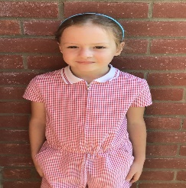

**Sycamores Star of the Week**



Millie for showing perseverance in reading and great determination in Forest school.

For always working hard and being amazing.

For always demonstrating kindness both inside and outside of the classroom.

**Class Attendance**

Willows – 94.74%

Sycamores – 94.85%

Oaks – 94.44%

CHALLENGE

NURTURE

INSPIRE

CHALLENGE

NURTURE

INSPIRE

**Oaks Star of the Week**



**House Points for this week**

Stephen Hawkings – 205

Beatrix Potter – 268

Benjamin Britten – 458

Kelly Holmes – 235

For great work and determination in her writing this week.



Willows: 1st Arlo

2nd Joel

Sycamores: 1st Molly

2nd Finlay

3rd Ned

Oaks: 1st Charlie T

2nd Charlie L

3rd Paige



Jack M M & Maisy – Rock Star

Arlo – Support Act



Congratulations to Jack D for completing **Tungsten** stage in Numbots this week.



**Sycamores Samba**

Reminder - Sycamores have their final Samba lesson on Tuesday 25th of March. The children would love to show their new Samba skills to their parents/carers. So we would like to invite you in to watch their final performance at 11am.

Can’t make it? Don’t worry, we will record the performance and post this on class Dojo.

**Reminders for Next Term:**

**Oaks Class** – PE Mondays & Tuesdays

**Sycamores Class** – PE Wednesdays & Thursdays

**Willows Class** – PE Tuesdays & Fridays

**Fridays Forest School lessons**– Year 2’s & Oaks class

**Monday – Friday** (3.15pm until 4.30pm/5pm) Little Legends after-school club

**Monday – Friday** (8am until 8.40am) Breakfast Club

**Mondays** – Year 6 SATs Club (3.15pm until 4.15pm)

**Mondays** – Years 3 – 4’s Art Club (3.15pm until 4.15pm)

**Mondays** – Green Finger Gardening club (3.15pm until 4.15pm)

**Tuesdays** – Years 5 – 6’s Art Club (3.15pm until 4.15pm)

**Wednesdays** – Funky Feet Street Dance Club (3.15pm until 4.15pm)

**Fridays** – Forest School club (3.15pm until 4.15pm)

**Science Week 10th – 14th March**

British Science Week

Open Afternoon

Monday 10th March 2pm

Woodton Primary School will be celebrating British Science Week with lots of fun science events for the children all week. Please come and join us on Monday 10th March at 2pm for a science afternoon where you can join in the science activities with your child!

We are looking forward to seeing you there!



**World Book Day - Thursday 6th March**

This year for World Book Day, we are **not** dressing up as a book character. Instead, we are asking the children to create a 'Book in a Box'. This is a shoe box, or similar, which is decorated inside with a image or an overview of a book they love. Please see the pictures below for ideas.

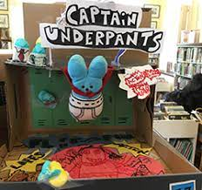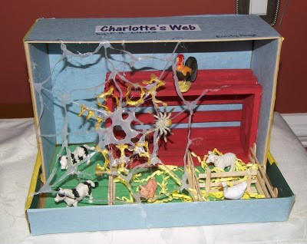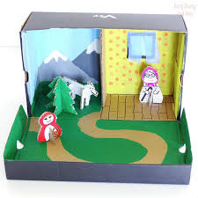

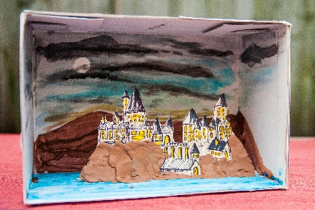

**Dates for the Diary**

**Friday 7th March** – Creative Evening 6pm

**Tuesday 4th March** – Parents Evening

**Wednesday 05th Mar** – Willows Dance Festival – Hobart High school

**Mon 10th – Fri 14th Mar** – Science Week

**Monday 10th March** – Open Science afternoon from 2pm – All Welcome

**Thursday 13th March** – Parents Evening

**Wednesday 26th Mar** – Sycamores Hockey Festival – Harleston Magpies (Details to follow)

**Monday 7th Apr – Wed 23rd Apr** – Easter Break

**Monday 5th May** – Bank Holiday Monday

**Wednesday 7th May** – Willows Multi-Skills Event – Hobart High School

**Thursday 8th May** – Sycamores Rugby Skills Event – Wymondham Rugby Club

**Mon 26th May – Fri 30th May** – Half Term

**Monday 9th June** – Selected Oaks Rounders Event – Hobart High school

**Tuesday 10th June** – Tempest Photos – Class & Year 6 Leavers

**Wednesday 18th June** – Oaks Athletics Event – UEA, Norwich

**Monday 23rd June** – Selected children for Tri-Golf – Bungay Golf Club

Website – <http://www.ellinghamandwoodton.co.uk/>