

*Issue No: 15 7 Date: Friday 24th January 2025*

*Our Newsletter comes out every Friday with updates about what the children have been up to during the week, information, things to celebrate and important dates for the diary. Please take the time to read through and if you have any questions, please speak to Mrs Taylor in the office.*

**This Week’s Achievements**

**Sycamores Star of the Week**

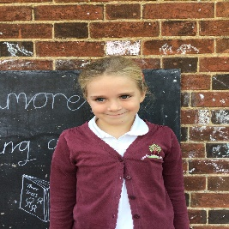

**Willows Star of the Week**

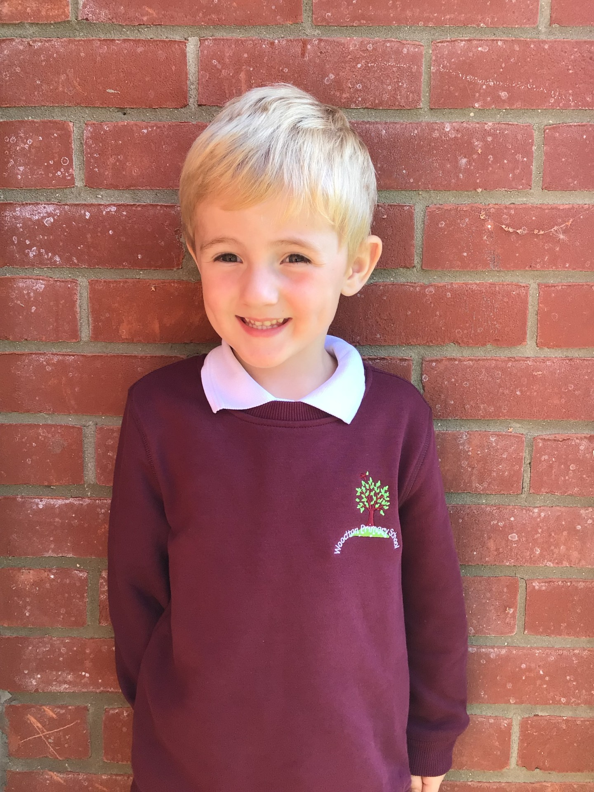

For wowing us with his can do attitude to his learning and always giving 100% in everything we do. Keep it up!

Millie for showing perseverance in reading and great determination in Forest school.

For completing a fantastic piece of work in French this week.

**Class Attendance**

Willows – 97.14%

Sycamores – 96.76%

Oaks – 94.44%

CHALLENGE

NURTURE

INSPIRE

CHALLENGE

NURTURE

INSPIRE

**Oaks Star of the Week**



**House Points for this week**

Stephen Hawkings – 309

Beatrix Potter – 264

Benjamin Britten – 317

Kelly Holmes – 378

For always trying her best with all her work and being a great cooperative partner in class.



No Numbots this week.



Willows: 1st Jack D

2nd Arlo

3rd Jude

Sycamores: 1st Finlay

2nd Maisy

3rd Jack MM

Oaks: 1st Flo

2nd Charlie T

3rd Jesse



Aria – Garage Rocker

Arlo – Wannabe

Phoebe - Gigger



**New to Class Dojo**

Mrs Thomas will be introducing a new weekly shout out of significant events or knowledge on Class Dojo. This will be called…



Keep an eye out for it!

**Reminders for Next Term:**

**Oaks Class** – PE Mondays & Tuesdays

**Sycamore Class** – PE Wednesdays & Thursdays

**Willows Class** – PE Tuesdays & Fridays

**Fridays Forest School lessons**– Reception & Year 1’s and Sycamores

**Monday – Friday** (3.15pm until 4.30pm/5pm) Little Legends after-school club

**Monday – Friday** (8am until 8.40am) Breakfast Club

**Mondays** – Year 6 SATs Club (3.15pm until 4.15pm)

**Mondays** – Years 3 – 4’s Art Club (3.15pm until 4.15pm)

**Tuesdays** – Years 5 – 6’s Art Club (3.15pm until 4.15pm)

**Wednesdays** – Funky Feet Street Dance Club (3.15pm until 4.15pm)

**Sycamores Samba**

Sycamores have their final Samba lesson on Tuesday 18th of March.

The children would love to show their new Samba skills to their parents/carers. So we would like to invite you in to watch their final performance at 11am. Can’t make it? Don’t worry, we will record the performance and post this on Class Dojo.



**Staff Car Park**

Please can we remind parents and carers that the staff car park is not to be used unless you have permission from the school.

**May we ask that this be shared with anyone that drops or collects your child/ren.**



**Dates for the Diary**

**Monday 27th Jan** – Sycamores Dodgeball – Hobart High School (Selected Sycamores children)

**Monday 3rd Feb** – Panathlon (Selected Sycamores children) – Long Stratton Leisure Centre

**Friday 7th Feb** – Happy Smiles Dentist visit

**Wednesday 12th Feb** – Sycamores ‘Spirit of the Games’ event – UEA, Norwich

**Mon 17th Feb – Fri 21st Feb** – Half Term

**Friday 7th March** – Creative Evening 6pm (Details to follow)

**Wednesday 12th Mar** – Willows Dance Festival – Hobart High school (Details to follow)

**Wednesday 26th Mar** – Sycamores Hockey Festival – Harleston Magpies (Details to follow)

**Monday 7th Apr – Wed 23rd Apr** – Easter Break

**Monday 5th May** – Bank Holiday Monday

**Wednesday 7th May** – Willows Multi-Skills Event – Hobart High School

**Thursday 8th May** – Sycamores Rugby Skills Event – Wymondham Rugby Club

**Mon 26th May – Fri 30th May** – Half Term

**Monday 9th June** – Selected Oaks Rounders Event – Hobart High school

**Tuesday 10th June** – Tempest Photos – Class & Year 6 Leavers

**Wednesday 18th June** – Oaks Athletics Event – UEA, Norwich

**Monday 23rd June** – Selected children for Tri-Golf – Bungay Golf Club

Website – <http://www.ellinghamandwoodton.co.uk/>