

*Issue No: 13 7 Date: Friday 10th January 2025*

*Our Newsletter comes out every Friday with updates about what the children have been up to during the week, information, things to celebrate and important dates for the diary. Please take the time to read through and if you have any questions, please speak to Mrs Taylor in the office.*

**This Week’s Achievements**

**Sycamores Star of the Week**



**Willows Star of the Week**



Millie for showing perseverance in reading and great determination in Forest school.

For inspiring us with her ‘can do’ attitude to her learning. Keep it up!

For always following our class expectations especially when showing respect to everyone.

**Class Attendance**

Willows – 98.25%

Sycamores – 97.22%

Oaks – 96.3%

CHALLENGE

NURTURE

INSPIRE

CHALLENGE

NURTURE

INSPIRE

**Oaks Star of the Week**



**House Points for this week**

Stephen Hawkings – 173

Beatrix Potter – 165

Benjamin Britten – 158

Kelly Holmes – 240

For making a determined effort in independent writing this week.



Willows: 1st Joel

Sycamores: 1st Evie

2nd Jack

3rd Finlay

Oaks: 1st Flo

2nd Sienna

3rd Daniel



Jude – Breakthrough



Congratulations to

**Arlo** for completing **Titanium**

stage in NumBots this week!



**Reminders for Next Term:**

**Oaks Class** – PE Mondays & Tuesdays

**Sycamore Class** – PE Wednesdays & Thursdays

**Willows Class** – PE Tuesdays & Fridays

**Fridays Forest School lessons**– Reception & Year 1’s and Sycamores

**Monday – Friday** (3.15pm until 4.30pm/5pm) Little Legends after-school club

**Monday – Friday** (8am until 8.40am) Breakfast Club

**Mondays** – Year 6 SATs Club (3.15pm until 4.15pm)

**Mondays** – Years 3 – 4’s Art Club (3.15pm until 4.15pm)

**Tuesdays** – Years 5 – 6’s Art Club (3.15pm until 4.15pm)

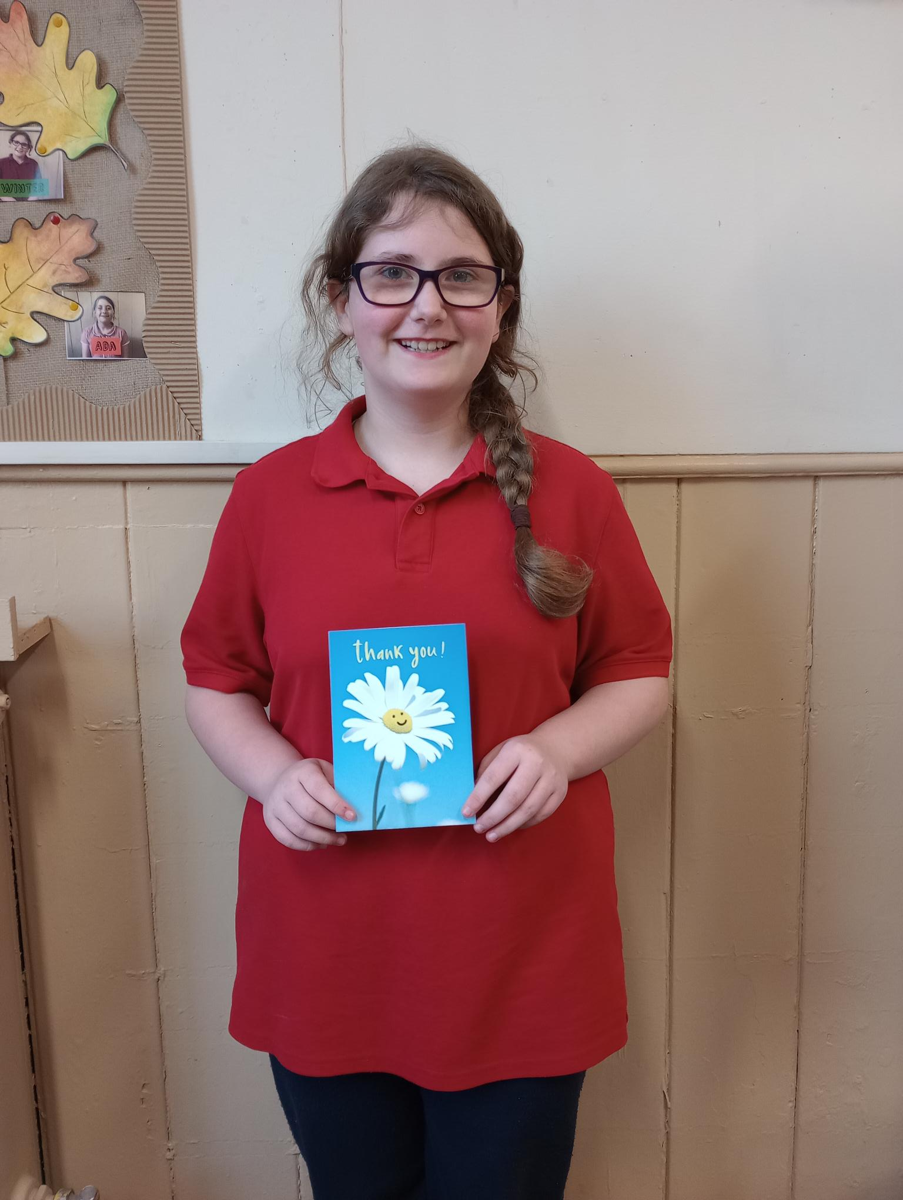

**A big WELL DONE to Winter for her church reading at the Christmas Carol Service.**

**School Uniform**

Attached to the newsletter email is our full school uniform list.

Please may we ask that the correct uniform and PE kit is worn each day.

The full range of uniform is available from the MyClothing website.

<https://myclothing.com/woodton-primary-school/7833.school>

Alternatively, there are similar options from local supermarkets.





**Dates for the Diary**

**Tuesday 7th Jan** – Sycamores Samba Drumming (Every Tuesday)

**Tuesday 21st Jan** – Active Leaders Training – UEA (Selected Oaks children)

**Monday 27th Jan** – Sycamores Dodgeball – Hobart High School (Selected Sycamores children)

**Monday 3rd Feb** – Panathlon Yrs 3-6 – Long Stratton

**Friday 7th Feb** – Happy Smiles Dentist visit

**Wednesday 12th Feb** – Spirit of the Games – UEA

**Mon 17th Feb – Fri 21st Feb** – Half Term

Website – <http://www.ellinghamandwoodton.co.uk/>