

*Issue No: 8 Date: Friday 15th Nov 2024*

*Our Newsletter comes out every Friday with updates about what the children have been up to during the week, information, things to celebrate and important dates for the diary. Please take the time to read through and if you have any questions, please speak to Mrs Taylor in the office.*

**This Week’s Achievements**

**Sycamores Star of the Week**

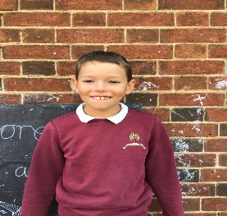

**Willows Star of the Week**

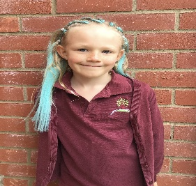

For amazing participation in every lesson and fabulous art skills this week!

Millie for showing perseverance in reading and great determination in Forest school.

For having a positive attitude and being confident to work independently.

**Class Attendance**

Willows – 97.81%

Sycamores – 97.37%

Oaks – 93.52%

CHALLENGE

NURTURE

INSPIRE

CHALLENGE

NURTURE

INSPIRE

**Oaks Star of the Week**

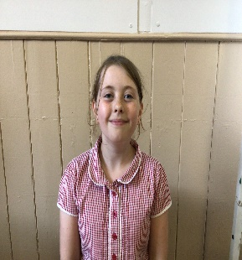

**House Points for this week**

Stephen Hawkings – 323

Beatrix Potter – 263

Benjamin Britten – 345

Kelly Holmes – 266

For fantastic effort in her English work recently.



Willows: 1st Phoebe

Sycamores: 1st Ned

2nd Bea

3rd Maisy

Oaks: 1st Sienna

2nd Paige

3rd Isla



Sienna – Support Act

Lonnie – Breakthrough



Congratulations to

**Arlo** for completing **Tungsten** and **Jude** forcompleting **Bronze**

stages in NumBots this week!



**Tempest Photos**

All children had their individual and sibling photos took today.

They are bringin the proofs home with them, so please check school bags.

Ordering is easy by scanning the QR code that is on the proof paper.



**Reminders for this Term:**

**Oaks Class** – PE on Tuesdays & swimming on Wednesdays

**Sycamore Class** – PE on Wednesdays & Thursdays

**Willows Class** – PE Mondays & Fridays

**Fridays Forest School lessons**– Year 2’s and Oaks

**Whole Trip Hippodrome Trip**

**Thursday 12th December**

An email went out this week, giving details about the Hippodrome Trip that the PTA have organised for a whole school treat.

Please make sure that consent and payment is made by Friday 29th of November.



**Reminder**

Just a reminder about our school uniform, please make sure correct footwear is being worn. Also, no tattoos or nail varnish.

We advise that hair is tied back, especially for PE lessons too.



**All Saints Woodton Church**

**Candlelight Carol Service**

**Friday 20th December - 6pm**

**If any of our Oaks children would like to read in this service, please let the office know by Friday the 29th of November.**



**School Council**

**Say HI to our new school council!!**

*Isla* (R)

*Alfie*

*Phoebe*

*Maisy*

*Charlie Wh*

*Daniel*

*Lucy*

**Parent Forum – Behaviour Focus**

**Thursday 5th of December**

**from 2.30pm in the school hall**

**All parents are invited to come to a parent forum that will be focused on behaviour.**

**It will be an opportunity to speak Diane Perry-Yates our Chair of Governors, Mrs Thomas and Mrs Querelle.**



**Dates for the Diary**

**Thursday 28th Nov** – Parents Evening

**Monday 2nd Dec**  – Norwich Cathedral Trip – Whole school

**Friday 6th Dec** – 2nd round of Flu Vaccination

**Thursday 12th Dec** – Trip to the Hippodrome – Whole school

**Wednesday 18th Dec** – Willows Nativity (2pm)

**Wednesday 18th Dec** – School Christmas Lunch

**Wednesday 18th Dec** – Christmas Jumper Day

**Thursday 19th Dec** – Carol Service @ All Saints Woodton Church – 2pm

**Friday 20th Dec** – Last Day of term

**Tuesday 7th Jan** – First day of term

Website – <http://www.ellinghamandwoodton.co.uk/>