

*Issue No: 8 Date: Friday 15th Nov 2024*

*Our Newsletter comes out every Friday with updates about what the children have been up to during the week, information, things to celebrate and important dates for the diary. Please take the time to read through and if you have any questions, please speak to Mrs Taylor in the office.*

**This Week’s Achievements**

**Sycamores Star of the Week**

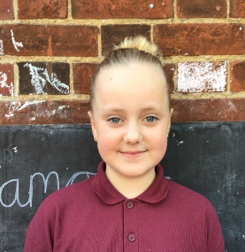

**Willows Star of the Week**

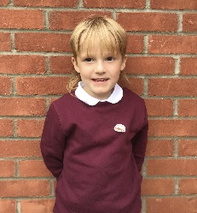

For being a great role model and giving everything 100%.

Millie for showing perseverance in reading and great determination in Forest school.

For completing some fantastic descriptive work in English this week.

**Class Attendance**

Willows – 98.25%

Sycamores – 88.6%

Oaks – 96.3%

CHALLENGE

NURTURE

INSPIRE

CHALLENGE

NURTURE

INSPIRE

**Oaks Star of the Week**

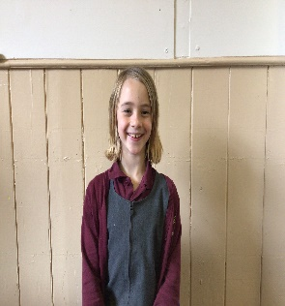

**House Points for this week**

Stephen Hawkings – 242

Beatrix Potter – 193

Benjamin Britten – 281

Kelly Holmes – 244

For great participation and enthusiasm in every lesson.



Congratulations to

**Arlo** for completing **Chrome** and **Arlo** & **Noah** forcompleting **Glass**

stages in NumBots this week!



Willows: 1st Phoebe

Sycamores: 1st Ned

2nd Finlay

3rd Molly

Oaks: 1st Isla



Lonnie – Gigger

Evie – Support Act



**Reminders for this Term:**

**Oaks Class** – PE on Tuesdays & swimming on Wednesdays

**Sycamore Class** – PE on Wednesdays & Thursdays

**Willows Class** – PE Mondays & Fridays

**Fridays Forest School lessons**– Year 2’s and Oaks

Competition Winner

**CONGRATULATIONS!!**

Thank you to everyone that handed in their amazing designs for the ‘Behaviour Expectations’ poster competition.

Well Done to Bethany Kay for the winning design, this will be displayed across the federation.

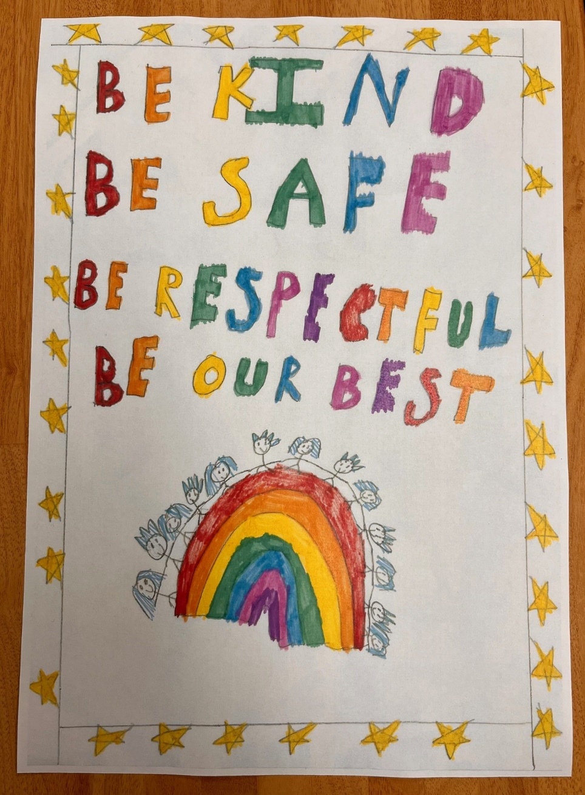

**Reminder**

Just a reminder about our school uniform, please make sure correct footwear is being worn. Also, no tattoos or nail varnish.

We advise that hair is tied back, especially for PE lessons too.



**Reclaim the Rain Project**

The first of many projects from Reclaim the Rain have started, we have some new Sud Pods in the playground, which are large planters with seating. These are connected to the schools drainpipes, which helps put any rainwater to good use. RtR are also clearing out our internal courtyard and will be adding two more Sud pods in there.

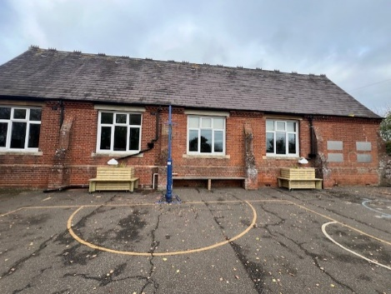

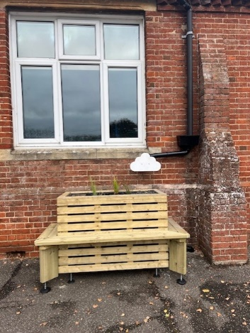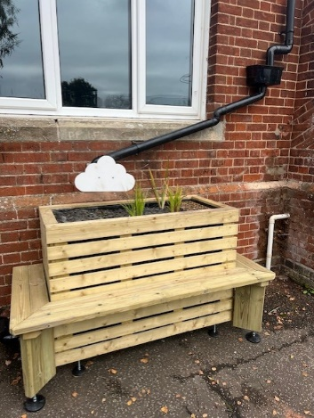

**Dates for the Diary**

**Friday 22nd Nov** – Tempest individual and sibling photos

**Thursday 28th Nov** – Parents Evening

**Monday 2nd Dec**  – Norwich Cathedral Trip – Whole school

**Friday 6th Dec** – 2nd round of Flu Vaccination

**Thursday 12th Dec** – Trip to the Hippodrome – Whole school (Details to follow)

**Wednesday 18th Dec** – School Christmas Lunch

**Wednesday 18th Dec** – Christmas Jumper Day

**Friday 20th Dec** – Last Day of term

**Tuesday 7th Jan** – First day of term

Website – <http://www.ellinghamandwoodton.co.uk/>