

*Issue No: 7 Date: Friday 08th Nov 2024*

*Our Newsletter comes out every Friday with updates about what the children have been up to during the week, information, things to celebrate and important dates for the diary. Please take the time to read through and if you have any questions, please speak to Mrs Taylor in the office.*

**This Week’s Achievements**

**Sycamores Star of the Week**

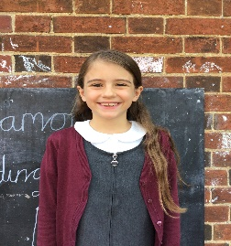

**Willows Star of the Week**

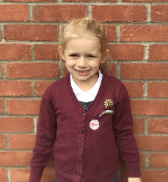

For always giving 100% and for being amazing.

Millie for showing perseverance in reading and great determination in Forest school.

For consistently putting in 100% effort in all her learning.

**Class Attendance**

Willows – 98.68%

Sycamores – 84.21%

Oaks – 98.61%

CHALLENGE

NURTURE

INSPIRE

CHALLENGE

NURTURE

INSPIRE

**Oaks Star of the Week**

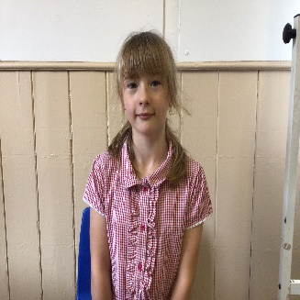

**House Points for this week**

Stephen Hawkings – 198

Beatrix Potter – 149

Benjamin Britten – 245

Kelly Holmes – 165

For great enthusiasm and participation in RE this week.



Congratulations to the following for completing

**Maci & Ella** for **Brass**

**Jude** for **Titanium**

**Noah & Arlo** for **Steel**

**Noah** for **Chrome**

**Alannah** for **Tungsten**

**Jude** for **Aluminum, Kevlar & Carbon Fibre**

stages in NumBots this week!



Willows: 1st Phoebe

Sycamores: 1st Molly

2nd Finlay

Oaks: 1st Sienna

2nd Paige

3rd Kian



No Rock Legends this week!



**Reminders for this Term:**

**Oaks Class** – PE on Tuesdays & swimming on Wednesdays

**Sycamore Class** – PE on Wednesdays & Thursdays

**Willows Class** – PE Mondays & Fridays

**Fridays Forest School lessons**– Year 2’s and Oaks

**Whole School trip to Norwich Cathedral**

**Monday 2nd of December 2024**

We still have some outstanding payments for the Cathedral trip, these were due in on the 6th of November.

If you have not paid already, please bring payment into the school by Monday at the latest.

**Thank you!**



**Tesco Stronger Starts Grant**

We have had some amazing news this week!

Tesco have informed us that after all the blue tokens were counted, we won second prize of £1000 to go towards our Wellbeing garden project.

Thank you to everyone that supported this.

We will update you all shortly with how the money will be spent on the Wellbeing Garden.

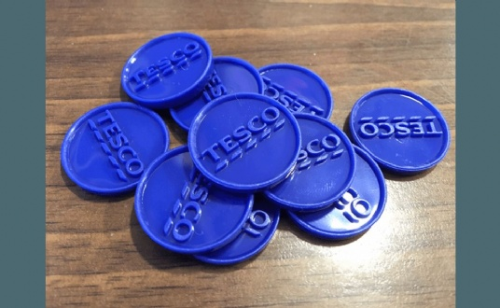

**Long Term Dates for the Diary**

**Tuesday 12th Nov** – Parents Evening

**Wednesday 13th Nov** – Reception Benjamin & Bethany Road Safety (AM)

**Wednesday 13th Nov** – Year 2 Road Safety (PM)

**Friday 22nd Nov** – Tempest individual and sibling photos

**Thursday 28th Nov** – Parents Evening

**Monday 2nd Dec**  – Norwich Cathedral Trip – Whole school

**Friday 6th Dec** – 2nd round of Flu Vaccination

**Thursday 12th Dec** – Trip to the Hippodrome – Whole school (Details to follow)

**Wednesday 18th Dec** – School Christmas Lunch

**Wednesday 18th Dec** – Christmas Jumper Day

**Friday 20th Dec** – Last Day of term

**Tuesday 7th Jan** – First day of term

Website – <http://www.ellinghamandwoodton.co.uk/>