

*Issue No: 4 Date: Friday 4th Oct 2024*

*Our Newsletter comes out every Friday with updates about what the children have been up to during the week, information, things to celebrate and important dates for the diary. Please take the time to read through and if you have any questions, please speak to Mrs Taylor in the office.*

**This Week’s Achievements**

**Sycamores Star of the Week**

**Willows Star of the Week**

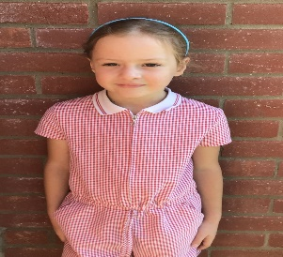

Millie for showing incredible resilience and having a ‘can do’ attitude in all her learning this week.

For being a superstar this week, following all our school expectations and being a fantastic role model. Keep it up Phoebe!

Millie for showing perseverance in reading and great determination in Forest school.

**Class Attendance**

Willows – 93.75%

Sycamores – 97.27%

Oaks – 95.35%

CHALLENGE

NURTURE

INSPIRE

CHALLENGE

NURTURE

INSPIRE

**Oaks Star of the Week**

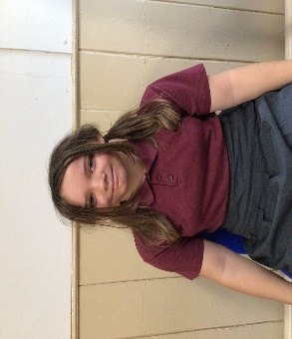

**House Points for this week**

Stephen Hawkings – 277

Beatrix Potter – 254

Benjamin Britten – 175

Kelly Holmes – 248

For being kind and respectful to everyone in class and for making a fantastic effort with her work this week.



Willows: None This Week!

Sycamores: 1st Ned

2nd Charlie Will

3rd Theo

Oaks: 1st Hector

2nd Flo



No Rock Legends this Week!



No Numbots this week!



**Tesco – Stronger Starts**

**Wellbeing Garden**

Thank you to everyone who has been supporting the blue token booth in Beccles and Southwold Tesco stores.

It is the final weekend to post those last minute tokens.

Please spread the word to your family and friends!!

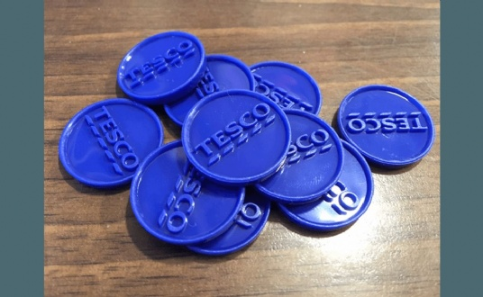

Reminders for Next Term:

**Oaks Class** – PE on Tuesdays & swimming on Wednesdays

**Sycamore Class** – PE on Mondays & Wednesdays

**Willows Class** – PE Mondays & Fridays

**Fridays Forest School lessons**– Year 1’s and Reception and Sycamores

**Wellbeing Gardening Club** – Monday afternoons (Mixed groups)

**PTA Monster Mash**

**Halloween Party**

**All Welcome**

**Wednesday 23rd October**

**5.30pm until 7.30pm**

**At Broome Village Hall**

**More details to follow!**

**OAKS – REMINDER**

All Oaks children will require a packed lunch on Tuesdays and Thursdays.

Oaks will now be walking back to school on Fridays in time for lunch, so hot dinners can be ordered.



**No Parking in the Staff Car Park**

Unless you have been given permission, NO ONE should be parking in the staff car park. This includes breakfast club and after-school club, and late arrivals.



Just a reminder that we have a competition running at the minute to design some new Behaviour Expectation posters to display around our schools.  
Our Expectations are:  
Be Kind,  
Be Safe,  
Be Respectful,  
Be Our Best.  
  
**Entries will close on Friday 4th October when winners will be chosen.**

**Long Term Dates for the Diary**

**Wednesday 9th Oct**  – Cross Country at Langley (Sycamores)

**Thursday 10th Oct** – Hello Yellow – Non-uniform with something yellow + £1 donation per child

**Thursday 10th Oct** – Hello Yellow Cake Stall 3pm

**Friday 11th Oct** – Happy Smiles Club – Whole school

**Mon 14th – Fri 18th Oct** – Space Week

**Thursday 17th Oct** – Tempest individual and sibling photos

**Wed 23rd Oct** – Monster Mash Halloween Party @ Broome Village Hall

**Thursday 24th Oct** – Harvest Festival TBC

**Thursday 24th Oct** – Last Day of Term

**Monday 4th Nov** – Return to school

**Wednesday 6th Nov** – PTA Annual General Meeting

**Monday 2nd Dec**  – Norwich Cathedral Trip – Whole school Details to follow

**Friday 20th Dec** – Last Day of term

Website – <http://www.ellinghamandwoodton.co.uk/>