

*Issue No: 5 Date: Friday 11th Oct 2024*

*Our Newsletter comes out every Friday with updates about what the children have been up to during the week, information, things to celebrate and important dates for the diary. Please take the time to read through and if you have any questions, please speak to Mrs Taylor in the office.*

**This Week’s Achievements**

**Sycamores Star of the Week**

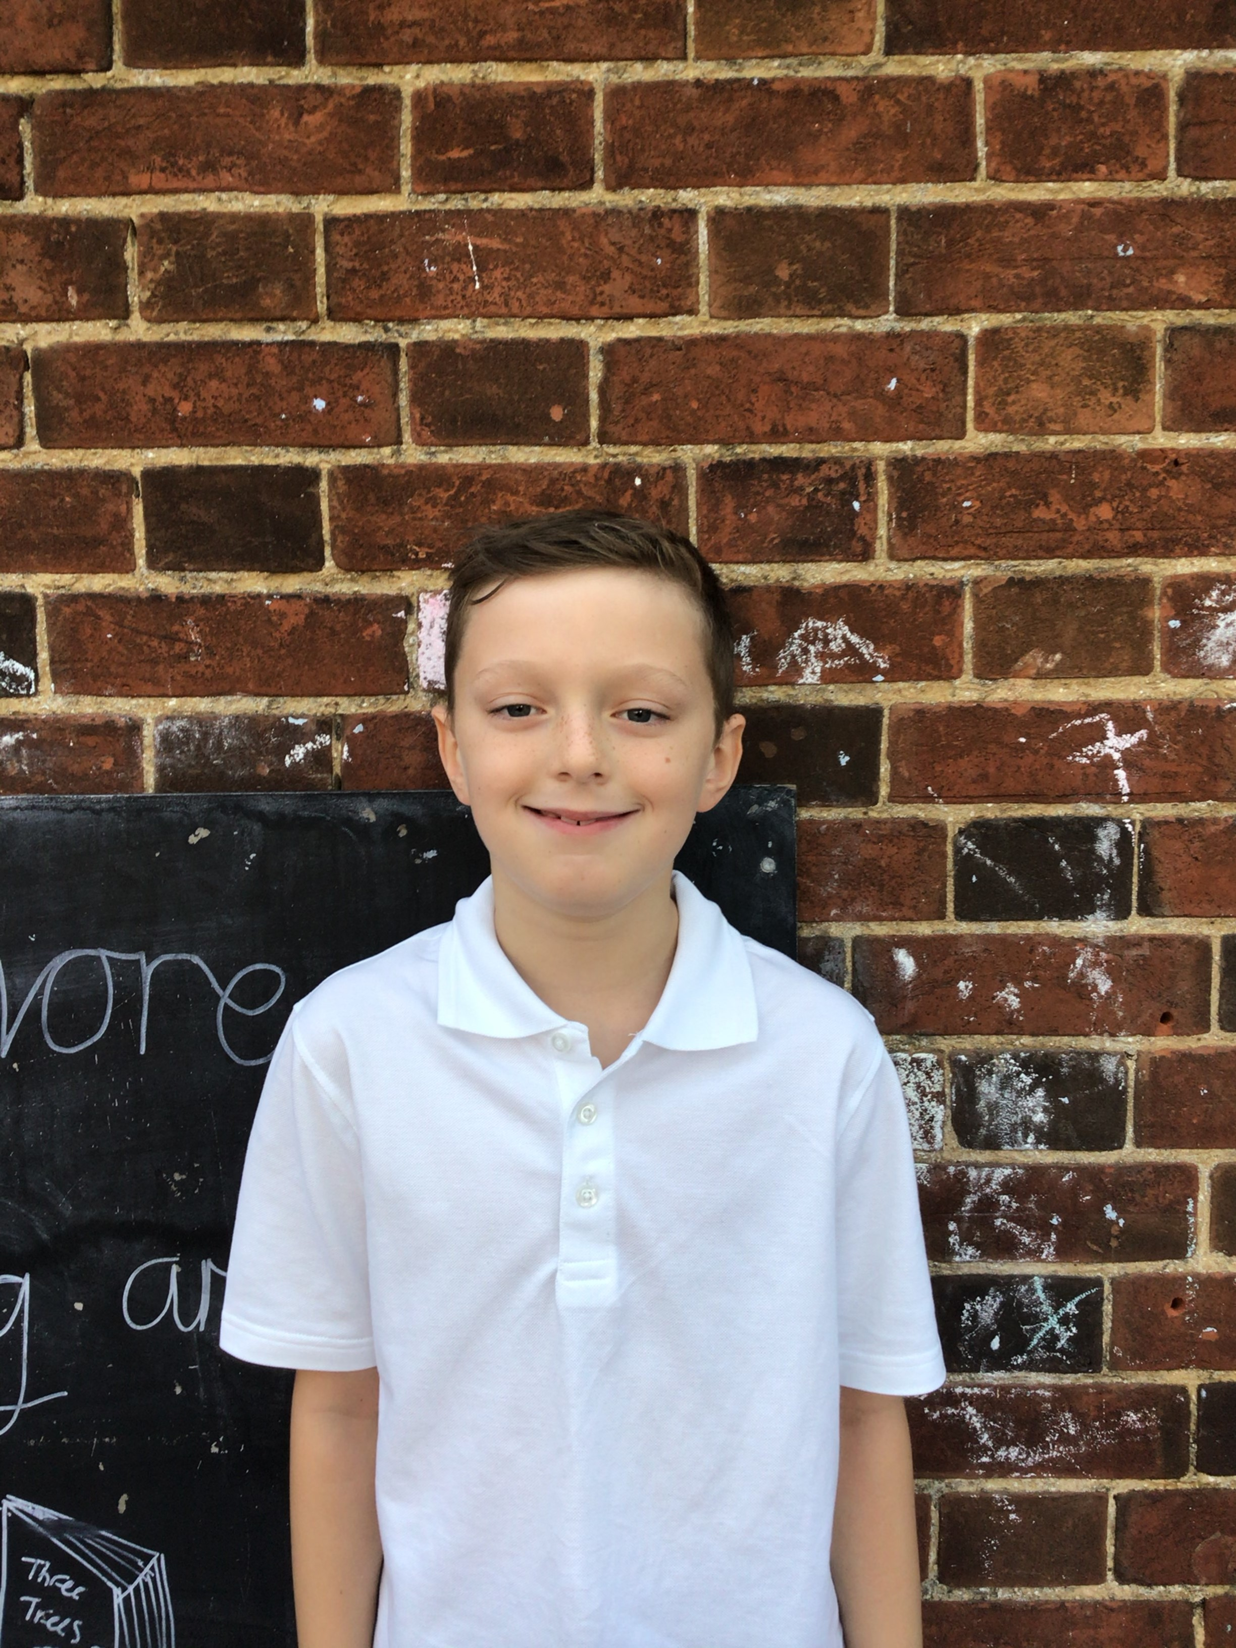

**Willows Star of the Week**

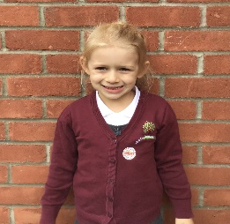

For always being willing to learn and for being respectful in class.

Millie for showing perseverance in reading and great determination in Forest school.

For completing a fantastic piece of independent writing in English this week.

**Class Attendance**

Willows – 97.92%

Sycamores – 96.67%

Oaks – 100%

CHALLENGE

NURTURE

INSPIRE

CHALLENGE

NURTURE

INSPIRE

**Oaks Star of the Week**

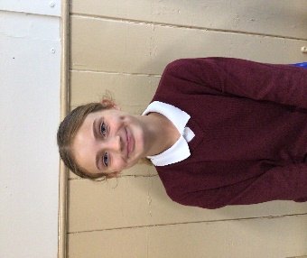

**House Points for this week**

Stephen Hawkings – 227

Beatrix Potter – 256

Benjamin Britten – 111

Kelly Holmes – 239

For always showing respect to others and having a positive attitude everyday.



Willows: None This Week!

Sycamores: 1st Evie

2nd Ned

3rd Courbon

Oaks: 1st Sienna



Sienna – Gigger

Evie – Breakthrough

Lonnie – Busker

Courbon - Support



Congratulations to

**Cleo** for completing the **Copper** stage in NumBots this week!



**HELLO YELLOW**

Thank you to everyone that supported Hello Yellow this year by wearing something yellow on Thursday and donating to the YoungMinds charity.

So far, we have raised as a federation, an amazing total of £170.50.

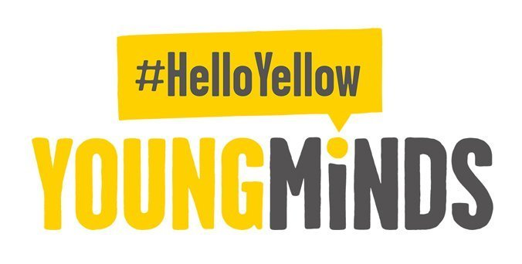

**HELLO YELLOW**

DAFFODIL BULBS WANTED!!

To continue with our daffodil display on the school grass bank, we would love any donations of daffodil bulbs to show our support for all mental health.

Please bring any directly into the school office.



**First Class Photo**

Please look out for the Beccles & Bungay Journal next Friday (18th October), as our little Reception children from Willows class will be in the BBJ ‘First Class Supplement’.

**Sycamores – Cross Country**

Well Done to our Sycamores class, for putting full effort into the Hobart Cluster cross country event at Langley school on Wednesday.

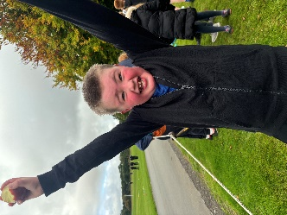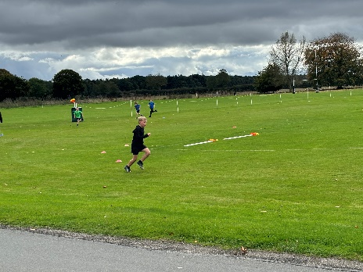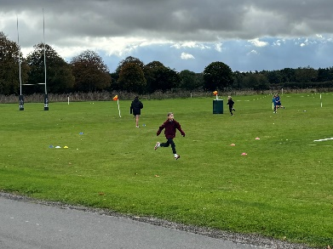

**PTA Monster Mash**

**Halloween Party**

**All Welcome**

**Wednesday 23rd October**

**5.30pm until 7.30pm**

**At Broome Village Hall**

**More details to follow!**

Reminders for this term:

**Oaks Class** – PE on Tuesdays & swimming on Wednesdays

**Sycamore Class** – PE on Mondays & Wednesdays

**Willows Class** – PE Mondays & Fridays

**Fridays Forest School lessons**– Year 1’s and Reception and Sycamores

**Wellbeing Gardening Club** – Monday afternoons (Mixed groups)

**Absence due to Illness**

If your child is absent due to feeling poorly, please notify the school through your Pupil Asset Parent portal. You can record the absence and give a detailed reason through this section.



**Long Term Dates for the Diary**

**Mon 14th – Fri 18th Oct** – Space Week

**Wednesday 16th Oct** – Year 6 Code Breaking at Hobart High

**Wed 23rd Oct** – Monster Mash Halloween Party @ Broome Village Hall

**Thursday 24th Oct** – Visit to the Seething Observatory - Whole School (Details to follow)

**Thursday 24th Oct** – Harvest Festival TBC

**Thursday 24th Oct** – Last Day of Term

**Monday 4th Nov** – Return to school

**Wednesday 6th Nov** – PTA Annual General Meeting

**Thursday 7th Nov** – Oaks Rugby Festival (Details to follow)

**Wednesday 13th Nov** – Reception Benjamin & Bethany Road Safety (AM)

**Wednesday 13th Nov** – Year 2 Road Safety (PM)

**Friday 22nd Nov** – Tempest individual and sibling photos

**Monday 2nd Dec**  – Norwich Cathedral Trip – Whole school (Details to follow)

**Thursday 12th Dec** – Trip to the Hippodrome – Whole school (Details to follow)

**Friday 20th Dec** – Last Day of term

Website – <http://www.ellinghamandwoodton.co.uk/>