

*Issue No: 4 Date: Friday 4th Oct 2024*

*Our Newsletter comes out every Friday with updates about what the children have been up to during the week, information, things to celebrate and important dates for the diary. Please take the time to read through and if you have any questions, please speak to Mrs Taylor in the office.*

**This Week’s Achievements**

**Sycamores Star of the Week**

**Willows Star of the Week**

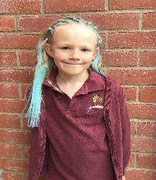

Millie for showing incredible resilience and having a ‘can do’ attitude in all her learning this week.

For producing excellent photos in our computing lesson.

Millie for showing perseverance in reading and great determination in Forest school.

**Class Attendance**

Willows – 93.75%

Sycamores – 97.27%

Oaks – 95.35%

CHALLENGE

NURTURE

INSPIRE

CHALLENGE

NURTURE

INSPIRE

**Oaks Star of the Week**

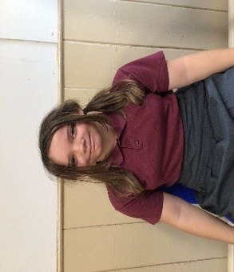

**House Points for this week**

Stephen Hawkings – 277

Beatrix Potter – 254

Benjamin Britten – 175

Kelly Holmes – 248

For being kind and respectful to everyone in class and for making a fantastic effort with her work this week.



Willows: None This Week!

Sycamores: 1st Ned

2nd Evie

3rd Charlie Wil

Oaks: 1st Paige

2nd Sienna



Lonnie – Garage Rocker



Congratulations to

**Jude & Alannah** for completing the **Glass,** **Alfie** for completing the **Copper** and **Jude** for also completing **Steel & Chrome** stages in NumBots this week!



**HELLO YELLOW**

DAFFODIL BULBS WANTED!!

To continue with our daffodil display on the school grass bank, we would love any donations of daffodil bulbs to show our support for all mental health.

Please bring any directly into the school office.



**HELLO YELLOW**

Thursday 10th October

**Non-Uniform with something Yellow**

Children are invited to come into school wearing something yellow to show their support for World Mental Health day.

The PTA have postponed the Hello Yellow cake sale, due to the bad weather that has been forecast,

A new date will be confirmed soon.

In place of bringing in a £1 donation, we have a ‘justgiving’ page to make it easier

[Ellingham VC and Woodton Primary School Federation is fundraising for Young Minds Trust (justgiving.com)](https://www.justgiving.com/page/ellingham-vc-primary-school-1727431660616)

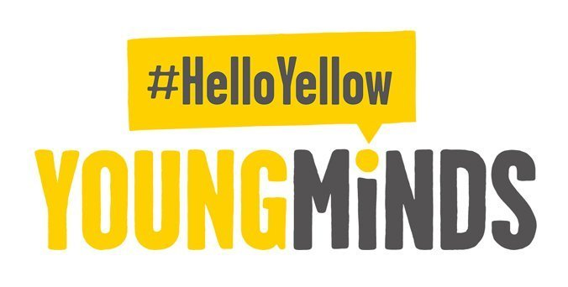

**Reminder - Oaks Class**

Just a reminder of the schedule for Oaks class next week. Please remember they will all require a packed lunch for Tuesday, Wednesday and Thursday. If you require a school packed lunch ordered, pleased order in the usual way. The swimming coach will be collecting from the village hall.

|  |  |  |  |  |  |
| --- | --- | --- | --- | --- | --- |
|  | **Monday** | **Tuesday** | **Wednesday** | **Thursday** | **Friday** |
| **Drop Off** | School | Village Hall | Village Hall | Village Hall | Village Hall |
| **Pick Up** | School | Village Hall | Village Hall | Village Hall | School |
| **Meals** | Any | Packed Lunch Only | Packed Lunch Only | Packed Lunch Only | Any |

**PTA Monster Mash**

**Halloween Party**

**All Welcome**

**Wednesday 23rd October**

**5.30pm until 7.30pm**

**At Broome Village Hall**

**More details to follow!**

Reminders for this term:

**Oaks Class** – PE on Tuesdays & swimming on Wednesdays

**Sycamore Class** – PE on Mondays & Wednesdays

**Willows Class** – PE Mondays & Fridays

**Fridays Forest School lessons**– Year 1’s and Reception and Sycamores

**Wellbeing Gardening Club** – Monday afternoons (Mixed groups)

**Sycamores - Cross Country**

Wednesday the 9th October

Please remember that all Sycamores children will require a packed lunch for this day, as they will be returning a little after lunch is served.



**Long Term Dates for the Diary**

**Wednesday 9th Oct**  – Cross Country at Langley (Sycamores)

**Thursday 10th Oct** – Hello Yellow – Non-uniform with something yellow + £1 donation per child

**~~Thursday 10~~~~th~~ ~~Oct~~** – Hello Yellow Cake Stall – New date to be confirmed

**Mon 14th – Fri 18th Oct** – Space Week

**Wed 23rd Oct** – Monster Mash Halloween Party @ Broome Village Hall

**Thursday 24th Oct** – Visit to the Seething Observatory - Whole School (Details to follow)

**Thursday 24th Oct** – Harvest Festival TBC

**Thursday 24th Oct** – Last Day of Term

**Monday 4th Nov** – Return to school

**Wednesday 6th Nov** – PTA Annual General Meeting

**Thursday 7th Nov** – Oaks Ruby Festival (Details to follow)

**Friday 22nd Nov** – Tempest individual and sibling photos

**Monday 2nd Dec**  – Norwich Cathedral Trip – Whole school (Details to follow)

**Thursday 12th Dec** – Trip to the Hippodrome – Whole school (Details to follow)

**Friday 20th Dec** – Last Day of term

Website – <http://www.ellinghamandwoodton.co.uk/>