

*Issue No: 31 Date: Friday 21st June 2024*

*Our Newsletter comes out every Friday with updates about what the children have been up to during the week, information, things to celebrate and important dates for the diary. Please take the time to read through and if you have any questions, please speak to Mrs Taylor in the office.*

**This Week’s Achievements**

**Sycamores Star of the Week**

**Willows Star of the Week**

Jack D for wowing us with his number knowledge in Maths and always being ready for a Maths challenge in Numbots.

Millie for showing perseverance in reading and great determination in Forest school.

Aria for giving 100% in all of her learning this week.

**Class Attendance**

Willows – 87.08%

Sycamores – 90.48%

Oaks – 88.73%

CHALLENGE

NURTURE

INSPIRE

CHALLENGE

NURTURE

INSPIRE

**Oaks Star of the Week**

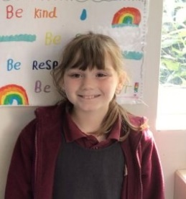

**House Points for this week**

Stephen Hawkings – 53

Beatrix Potter – 45

Benjamin Britten – 45

Kelly Holmes – 49

For great questions and engagement during our History workshop.



Willows: 1st Ned

Sycamores: 1st Finlay

2nd Isla

Oaks: 1st Jesse

2nd Riley

3rd Illiana



Felicity R – Gigger

Lilly-May - Busker



No Numbot Stages passed this

week!



Reminders for This Term:

**Oaks Class** – PE on Mondays & Tuesdays

**Sycamore Class** – PE on Wednesdays & Thursdays

**Willows Class** – PE Mondays & Fridays

**Fridays Forest School lessons**– Year 2’s & Oaks

**Wellbeing Gardening Club** – Monday afternoons (Mixed groups)

**Whole School Sponsored Walk**

**Friday 28th June**

As part of our support for Refugee week, we will be doing a whole school sponsored walk to raise money for the charity ‘Welcome Wheels’

Sponsor forms will be coming home today, please check your child’s bag.



**PTA Non-Uniform Day**

**Friday 28th June**

In exchange for a glass jar of sweets or treats for the Tombola at the Summer Fete.



**Sporting Achievements**

This week our Oaks class attended the Athletics event at the UEA.

They all did so well with each event they competed in. We had three medals won, Kian won a bronze medal for the 100m Sprint, Ava won a bronze medal, Leila won silver for long jump too.

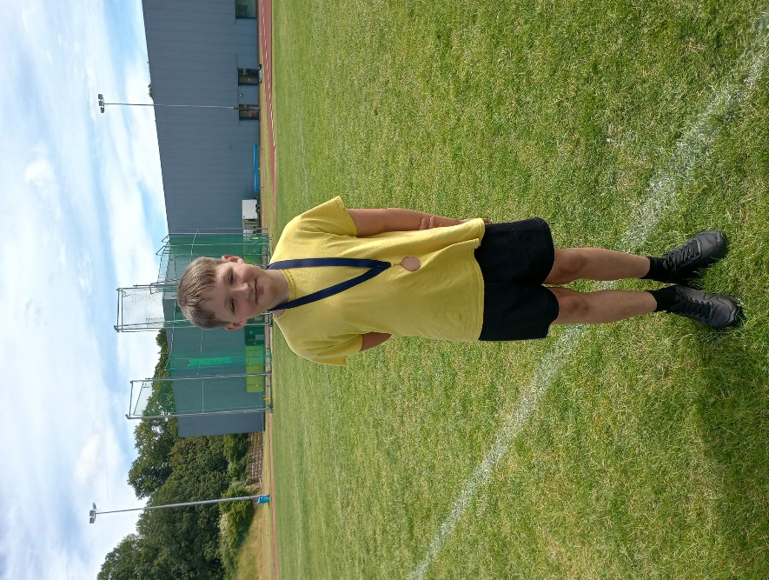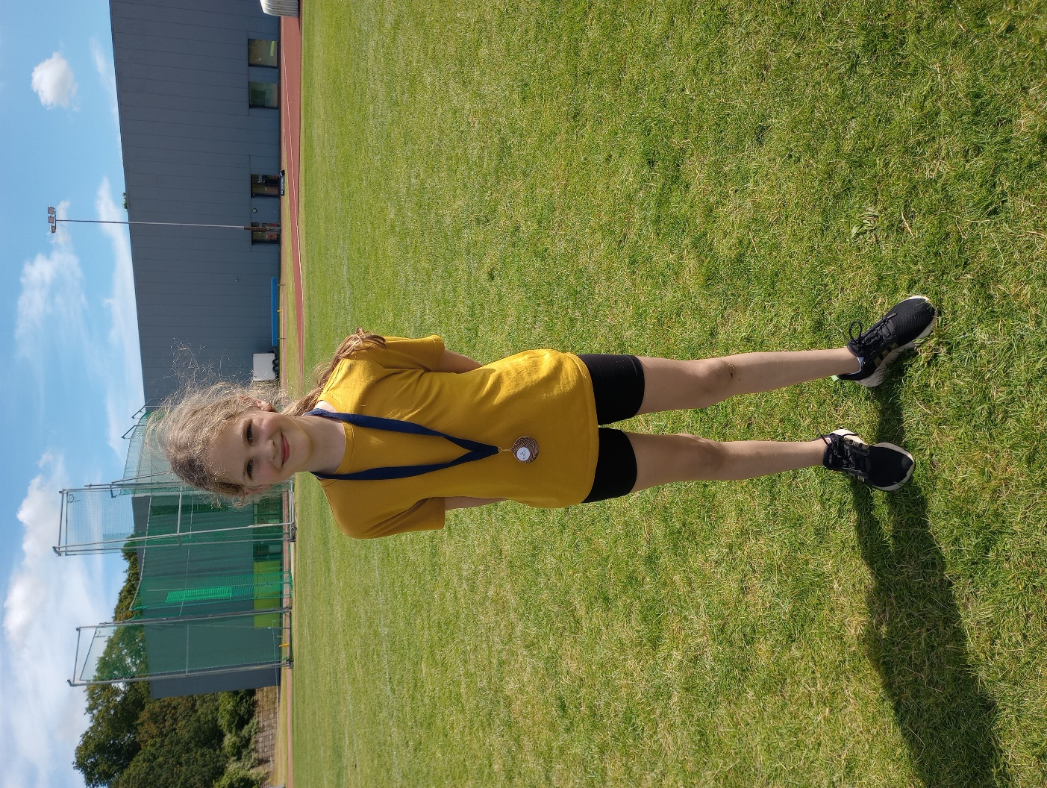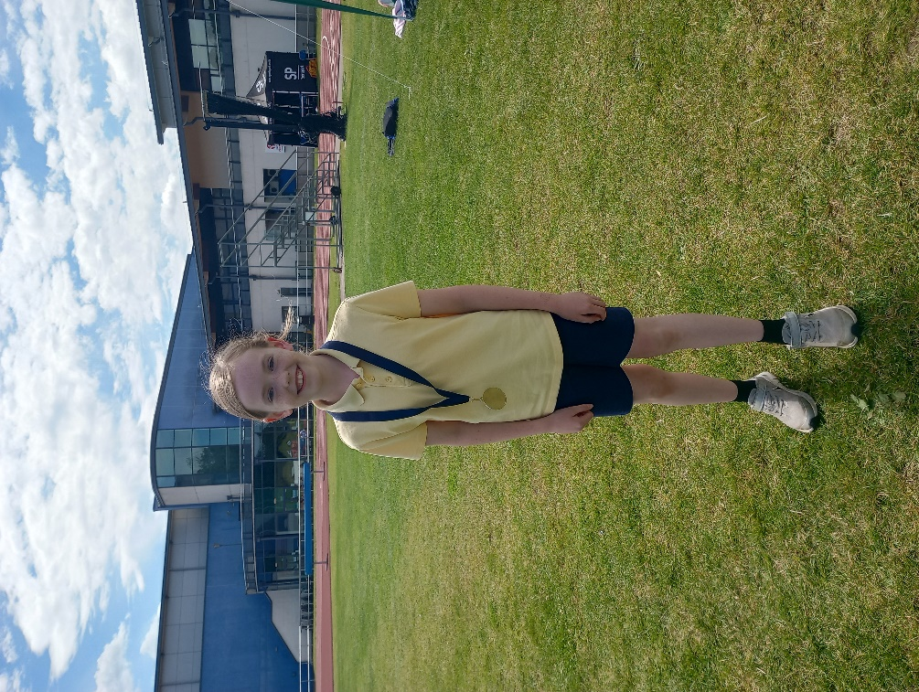

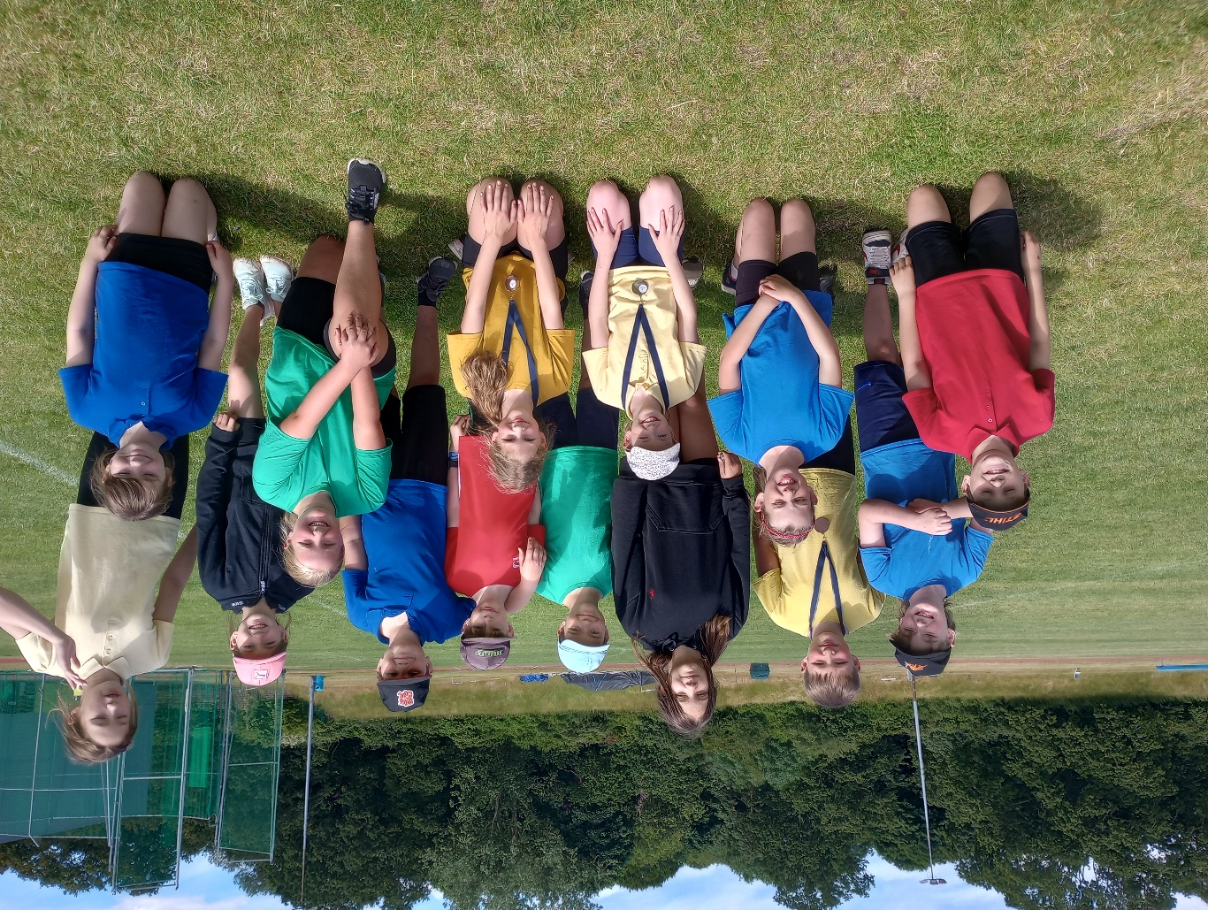

**Summer Fete Raffle Books**

With the Summer Fete approaching fast, Raffle tickets are now available to buy.

All children will be bringing home two raffle books each today. Tickets are £1 or £5 a book.

If you would like more books, these will be available to collect from the school office over the next two weeks.

All books must be back to school by Friday the 5th of July.



Wellbeing Gardening Club



**Donations:**

If anyone has a spare lawnmower or a wheelbarrow they no longer need, please speak to the school office, as the Wellbeing garden would greatly appreciate it.

THANK YOU.



**Forest School**

We have been notified that there has been some cases of Lymes disease reported in the area.

Please may we ask that for Forest school, children make sure they have a long sleeve top, long trousers and socks so they can tuck their trousers in.

If you would like some more information, please click on the link below.

<https://lymediseaseuk.com/awareness-schools-children/>



**Long Term Dates for the Diary**

**Monday 24th June** – Yr 5 & 6 Rounders event @ Hobart (3.45pm to 5.30pm)

**Tuesday 25th June** – Oaks Performance Rehearsal (At Woodton Village Hall all Day)

**Wednesday 26th June** – Sycamores Norfolk Show Trip

**Wed 26th & Thurs 27th June** – Year 6 Bungay High Transition Days

**Friday 28th June** – PTA Non-Uniform Day in exchange for a sweet-treat jar

**Friday 28th June** – Woodton Walk for Refugees

**Saturday 6th July** – Woodton School Summer Fete 12 – 3pm

**Mon 8th, Tues 9th & Wed 10th July** – Year 6 Hobart High Transition Days

**Thursday 11th July** – Woodton Sports Day

**Friday 12th July** – Oaks Performance – Rehearsal AM Performance PM (Woodton Village Hall all Day)

**Monday 15th July** – Year 6 Leavers Treat Day (Details to follow)

**Wednesday 17th July** – Whole school Inflatable Day (PTA’s Treat)

Website – <http://www.ellinghamandwoodton.co.uk/>