

*Issue No: 30 Date: Friday 14th June 2024*

*Our Newsletter comes out every Friday with updates about what the children have been up to during the week, information, things to celebrate and important dates for the diary. Please take the time to read through and if you have any questions, please speak to Mrs Taylor in the office.*

**This Week’s Achievements**

**Willows Star of the Week**

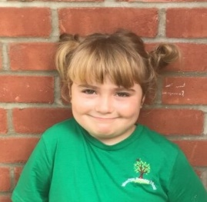

**Sycamores Star of the Week**



Millie for showing perseverance in reading and great determination in Forest school.

For showing amazing resilience and great participation on RE day.

For persevering in learning how to do the monkey bars!

**Class Attendance**

Willows – 91.67%

Sycamores – 80.95%

Oaks – 85.78%

CHALLENGE

NURTURE

INSPIRE

CHALLENGE

NURTURE

INSPIRE

**Oaks Star of the Week**

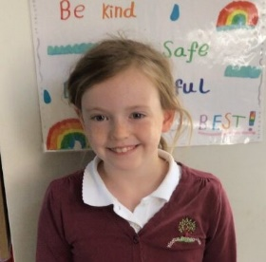

**House Points for this week**

Stephen Hawkings – 83

Beatrix Potter – 69

Benjamin Britten – 36

Kelly Holmes – 69

For amazing, accurate and neat work being cartographer on ‘Geography Day’.



Willows: 1st Jack MM

Sycamores: 1st Maisy

2nd Ada

3rd Flo

Oaks: 1st Jesse

2nd Riley



No Rock Legends this Week!



No Numbot Stages passed this

week!



**Chicken Pox**

We have had more cases of Chicken Pox reported in school this week. If you are unsure of the symptoms, please refer to the NHS website.

<https://www.nhs.uk/conditions/chickenpox/>

Reminders for Next Term:

**Oaks Class** – PE on Mondays & Tuesdays

**Sycamore Class** – PE on Wednesdays & Thursdays

**Willows Class** – PE Mondays & Fridays

**Fridays Forest School lessons**– Year 2’s & Oaks

**Wellbeing Gardening Club** – Monday afternoons (Mixed groups)

Online Safety Sessions

Miss Snelling will be leading some Online Safety sessions for parents across the federation.

Parents are invited to come into school to a brief session, which will then lead onto them joining their child’s class to play some online safety games.

Sycamores class – Friday 21st June from 2.15pm

ALL WELCOME!

**Class and Leavers Photos**

**Tuesday 18th June**

Tempest will be with us on Tuesday to take our class photos and our Year 6 leaver’s photos.

Please can Oaks children come into school in their uniform and bring their PE kits with them to change into.



**Hockey Lesson**

Ella from Langley school will be visiting us on Monday afternoon to run a Hockey lesson for our KS2 children.

Mrs Hinton will be swapping Sycamores PE lesson from Thursday to Monday for next week only, so children will need to come into school in their PE kit on Monday.

Oaks normally do PE on a Monday, so no change there.



Wellbeing Gardening Club



**Donations:**

If anyone has a spare lawnmower or a wheelbarrow they no longer need, please speak to the school office, as the Wellbeing garden would greatly appreciate it.

THANK YOU.

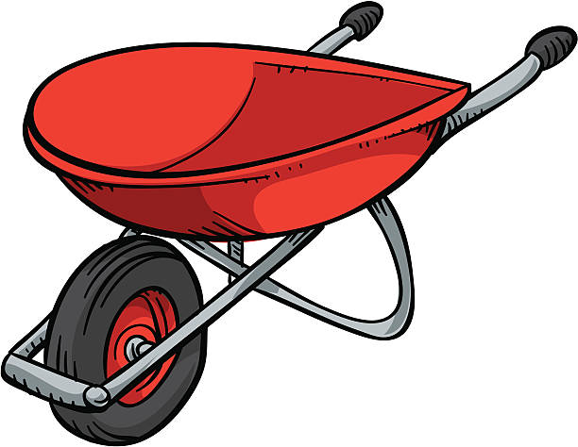

**Forest School**

We have been notified that there has been some cases of Lymes disease reported in the area.

Please may we ask that for Forest school, children make sure they have a long sleeve top, long trousers and socks so they can tuck their trousers in.

If you would like some more information, please click on the link below.

<https://lymediseaseuk.com/awareness-schools-children/>



**Long Term Dates for the Diary**

**Monday 17th June** – Sycamores and Oaks Hockey lesson

**Tuesday 18th June** – Tempest Class & Leavers Photos

**Wednesday 19th June** – Oaks Sutton Hoo remote workshop 12–1pm (packed lunch for this day pls)

**Thursday 20th June** – Oaks UEA Athletics event

**Friday 21st June** – Mini Monsters Visit

**Friday 21st June** – Online Safety Session for Sycamores Parents – 2.15pm

**Monday 24th June** – Yr 5 & 6 Rounders event @ Hobart (3.45pm to 5.30pm)

**Tuesday 25th June** – Oaks Performance Rehearsal (At Woodton Village Hall all Day)

**Wednesday 26th June** – Sycamores Norfolk Show Trip

**Wed 26th & Thurs 27th June** – Year 6 Bungay High Transition Days

**Mon 8th, Tues 9th & Wed 10th July** – Year 6 Hobart High Transition Days

**Thursday 11th July** – Woodton Sports Day

**Friday 12th July** – Oaks Performance – Rehearsal AM Performance PM (Woodton Village Hall all Day)

**Monday 15th July** – Year 6 Leavers Treat Day (Details to follow)

**Wednesday 17th July** – Whole school Inflatable Day (PTA’s Treat)

Website – <http://www.ellinghamandwoodton.co.uk/>