

*Issue No: 34 Date:Monday 15th July 2024*

*Our Newsletter comes out every Friday with updates about what the children have been up to during the week, information, things to celebrate and important dates for the diary. Please take the time to read through and if you have any questions, please speak to Mrs Taylor in the office.*

**This Week’s Achievements**

**Sycamores Star of the Week**

**Willows Star of the Week**

Our year 4’s for all achieving incredible multiplication check scores. You are all amazing!

All of Willows for making Mrs Querelle’s Mondays such a good start to her week over the last year.

Millie for showing perseverance in reading and great determination in Forest school.

**Class Attendance**

Willows – 90.42%

Sycamores – 96.43%

Oaks – 97.55%

CHALLENGE

NURTURE

INSPIRE

CHALLENGE

NURTURE

INSPIRE

**Oaks Star of the Week**

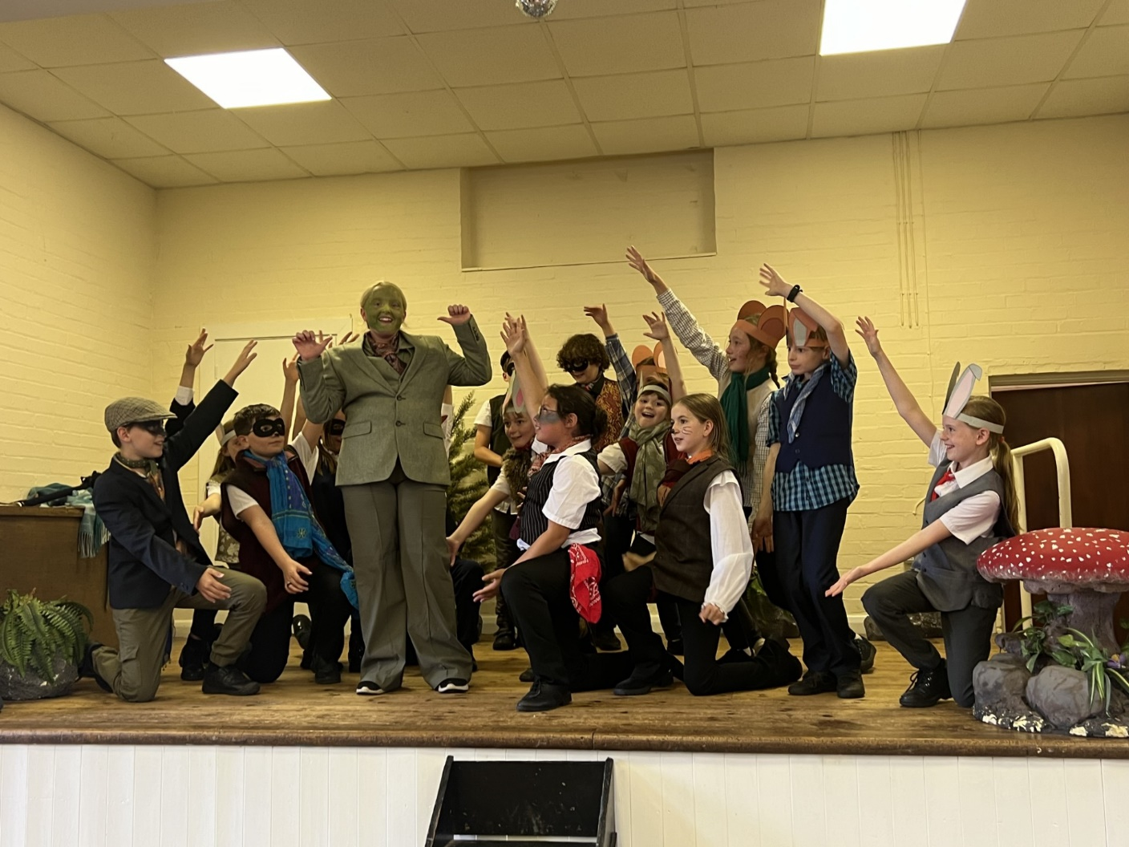

**House Points for this week**

Stephen Hawkings – 98

Beatrix Potter – 142

Benjamin Britten – 43

Kelly Holmes – 107

All of Oaks class, for their amazing performance in ‘Wind in the Willows’.



Willows: 1st Ned

2nd Jack M M

3rd Courbon

Sycamores: 1st Isla

2nd Flo

3rd Hector

Oaks: 1st Phoebe P

2nd Charlie T

3rd Jesse



No Rock Legends this Week!



Congratulations to

**Alfie** for completing the **Tin & Brass**, **Alannah** for completing **Chrome** stages in NumBots this week!



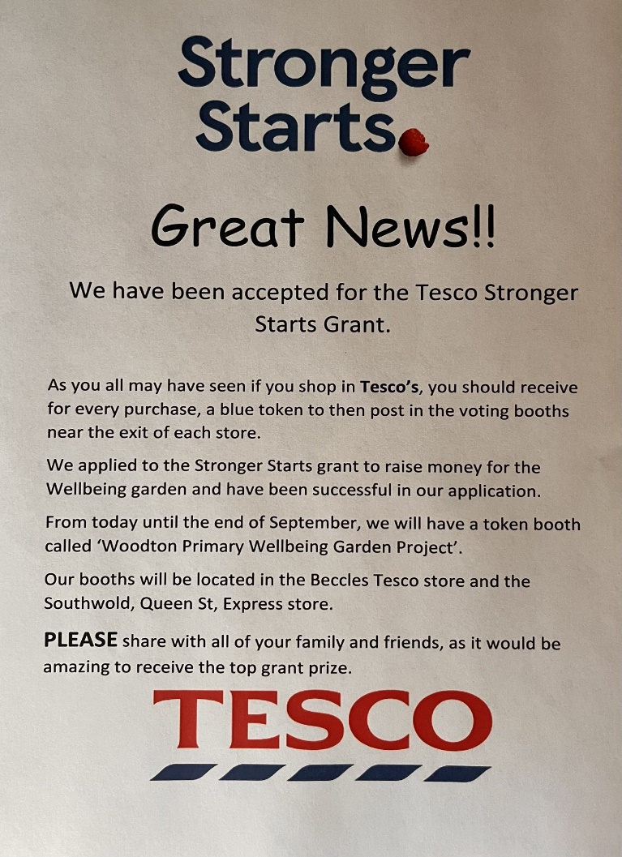

Reminders for Next Term:

**Oaks Class** – PE on Tuesdays & Wednesdays

**Sycamore Class** – PE on Wednesdays & Thursdays

**Willows Class** – PE Mondays & Fridays

**Fridays Forest School lessons**– Year 1’s and Reception and Sycamores

**Wellbeing Gardening Club** – Monday afternoons (Mixed groups)

**Whole School Inflatable Day**

**Wednesday 17th of July**

The PTA have very kindly organised a whole day of outdoor fun with a variety of inflatable fun for the children.

Please may we ask that all children come into school in their PE kits but must have long sleeve tops and trousers to change into, for safety.



**Reminders for September**

**Uniform**

Please may we ask that our correct uniform is worn from September, if you are unsure of what is required, please check on the school website for details.

**Car Park**

No one should be using the staff car park, unless you have received permission from the school.

**Payments**

All payments for dinners, clubs and trips, must be paid for in advance. If we do not receive payment, dinners will not be ordered and club and trip places will be cancelled.

**Long Term Dates for the Diary**

**Wednesday 17th July** – Whole school Inflatable Day (PTA’s Treat)

**Friday 19th July** – Leavers Assembly 9am – Parents/Carers welcome

**Friday 19th July** – End of Term

**Wednesday 4th September** – Return to school

Website – <http://www.ellinghamandwoodton.co.uk/>

**Have a lovely Summer break!**