

*Issue No: 1 Date:Monday 13th Sept 2024*

*Our Newsletter comes out every Friday with updates about what the children have been up to during the week, information, things to celebrate and important dates for the diary. Please take the time to read through and if you have any questions, please speak to Mrs Taylor in the office.*

**This Week’s Achievements**

**Sycamores Star of the Week**

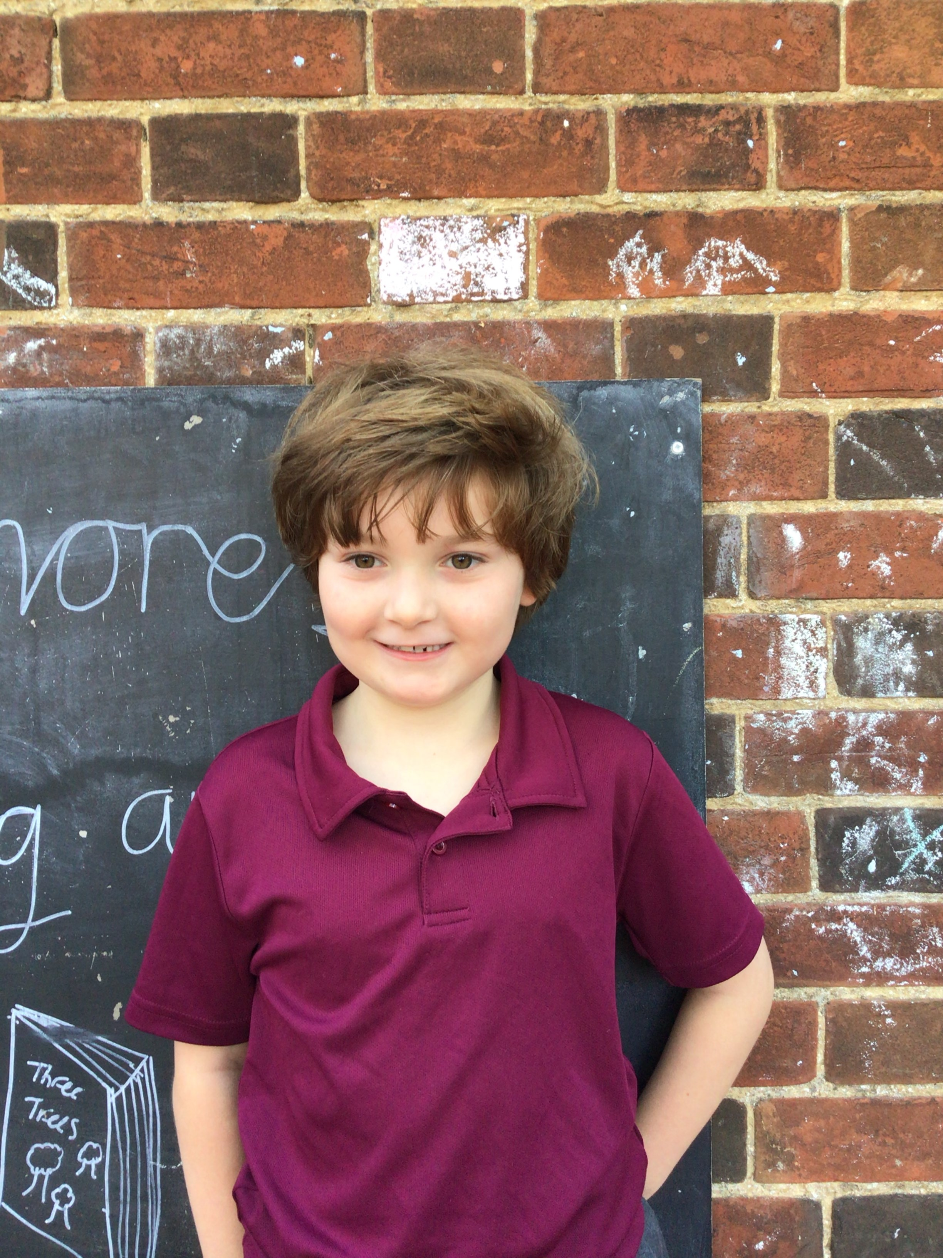

**Willows Star of the Week**

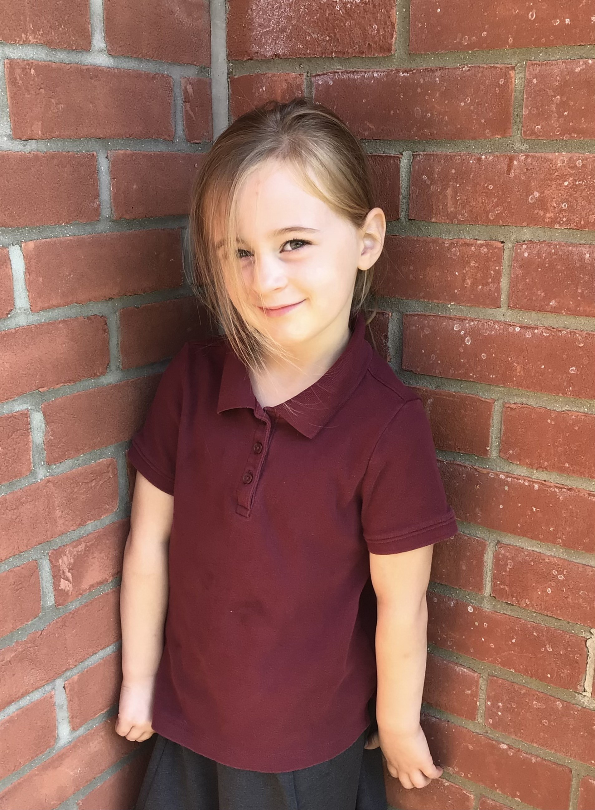

Millie for showing perseverance in reading and great determination in Forest school.

For having a positive attitude in all her learning this week.

For showing respect to everyone this week.

**Class Attendance**

Willows – 98.92%

Sycamores – 97.88%

Oaks – 97.37%

CHALLENGE

NURTURE

INSPIRE

CHALLENGE

NURTURE

INSPIRE

**Oaks Star of the Week**

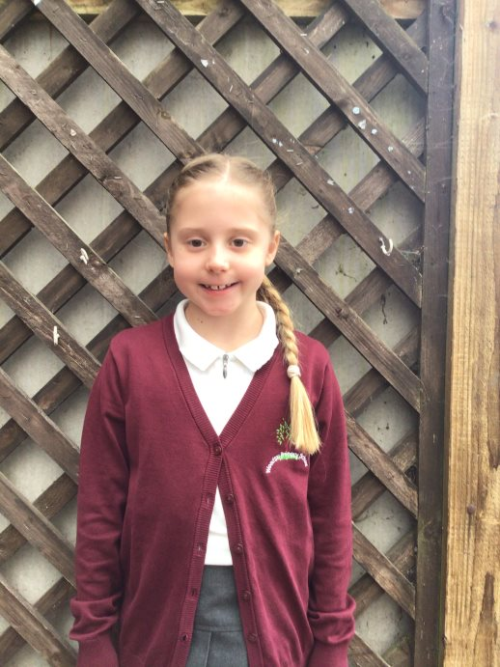

**House Points for this week**

Stephen Hawkings – 409

Beatrix Potter – 362

Benjamin Britten – 598

Kelly Holmes – 458

For settling into Oaks brilliantly and always being respectful to teachers and her classmates.



Willows: None This Week!

Sycamores: 1st Ned

2nd Courbon

3rd Jack

Oaks: 1st Flo

2nd Charlie T

3rd Paige



No Rock Legends this Week!



Congratulations to

**Dotty** for completing the **Glass** stage in NumBots this week!



**Tesco – Stronger Starts**

**Wellbeing Garden**

Thank you to everyone who has been supporting the blue token booth in Beccles and Southwold Tesco stores.

We only have a few weeks left now to add as many tokens as possible to be in for the chance of the top grant award.

Please spread the word to your family and friends!!

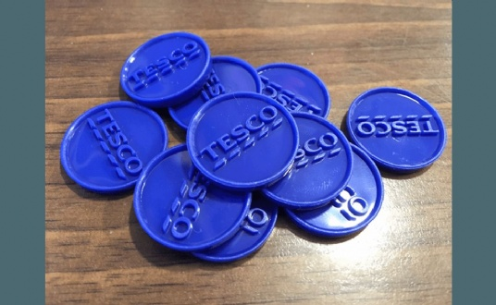

Reminders for Next Term:

**Oaks Class** – PE on Tuesdays & Wednesdays

**Sycamore Class** – PE on Wednesdays & Thursdays

**Willows Class** – PE Mondays & Fridays

**Fridays Forest School lessons**– Year 1’s and Reception and Sycamores

**Wellbeing Gardening Club** – Monday afternoons (Mixed groups)

**Free Pears**

There are still many Pears on the trees in the Wellbeing garden, please feel free to pick your own.



**Reminders**

**PE Kits**

Just a reminder that PE kits should only be black or blue track bottoms and no large logos on any items. Please can we advise that if your child is still learning to tie their laces that velcro trainers are used until your child is able to do their own laces up.

**Car Park**

No one should be using the staff car park, unless you have received permission from the school.

**Payments**

All payments for dinners, clubs and trips, must be paid for in advance. If we do not receive payment, dinners will not be ordered and club and trip places will be cancelled.

**Water Bottles**

Please remember that all children require a water bottle in school daily with only water inside.

**Jeans For Genes**

Friday the 20th September

Children are invited to come into school in non-uniform with something denim for a small donation of £1, to support the charity ‘Jeans for Genes’



**Long Term Dates for the Diary**

**Friday 20th Sept**  – Jeans for Genes Day

**Friday 20th Sept**  – Whole School Flu Vaccination

**Wednesday 9th Oct**  – Cross Country at Langley (Sycamores) Details to follow

**Thursday 10th Oct** – Hello Yellow – Non-uniform with something yellow + £1 donation per child

**Thursday 10th Oct** – Hello Yellow Cake Stall 3pm

**Friday 11th Oct** – Happy Smiles Club – Whole school

**Mon 14th – Fri 18th Oct** – Space Week

**Thursday 17th Oct** – Tempest individual and sibling photos

**TBC Oct** – Monster Mash Halloween Party

**Thursday 24th Oct** – Harvest Festival TBC

**Thursday 24th Oct** – Last Day of Term

**Monday 4th Nov** – Return to school

**Wednesday 6th Nov** – PTA Annual General Meeting

**Monday 2nd Dec**  – Norwich Cathedral Trip – Whole school Details to follow

**Friday 20th Dec** – Last Day of term

Website – <http://www.ellinghamandwoodton.co.uk/>