

*Issue No: 26 Date: Friday 10th May 2024*

*Our Newsletter comes out every Friday with updates about what the children have been up to during the week, information, things to celebrate and important dates for the diary. Please take the time to read through and if you have any questions, please speak to Mrs Taylor in the office.*

**This Week’s Achievements**

**Willows Star of the Week**

**Sycamores Star of the Week**



Jack D for being nurturing to others and putting his all into everything.

Millie for showing perseverance in reading and great determination in Forest school.

For being a fantastic mathematician this week when looking at decimals.

**Class Attendance**

Willows – 96%

Sycamores – 94.29%

Oaks – 97.06%

CHALLENGE

NURTURE

INSPIRE

CHALLENGE

NURTURE

INSPIRE

**Oaks Star of the Week**



**House Points for this week**

Stephen Hawkings – 61

Beatrix Potter – 76

Benjamin Britten – 69

Kelly Holmes – 60

For excellent understanding of 12 and 24 clocks in our outdoor Math’s lesson this week.



Congratulations to

**Joel** for completing the **Glass and Chrome** stages in NumBots this week!



Willows: 1st Ned

2nd Courbon

3rd Lilly-May

Sycamores: 1st Flo

2nd Alana

3rd Daniel

Oaks: 1st Charlie T

2nd Olivia

3rd Illiana



Headliner - Jesse



Reminders for This Term:

**Oaks Class** – PE on Mondays & Tuesdays

**Sycamore Class** – PE on Wednesdays & Thursdays

**Willows Class** – PE Mondays & Fridays

**Fridays Forest School lessons**– Sycamores & Reception/Year 1’s

Water Timer Science Challenge

Congratulations to the winners of our Science Week challenge to make a water clock to time exactly one minute. Well done to all the children for showing their great science skills and ingenuity in the challenge! Charlie L took the award for the most accurate and Daniel, Hector, Charlie W and Olivia for the best decorated. Thank you also to our fantastic science ambassadors for helping with the judging and to our Ogden Trust partnership for providing a small prize for everyone for taking part.

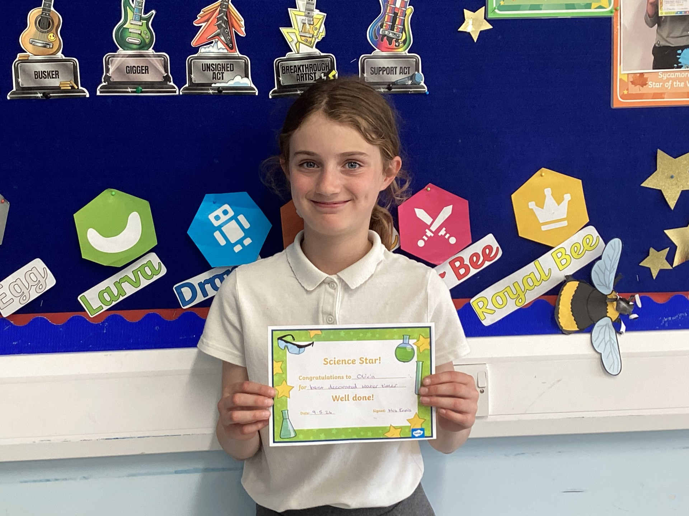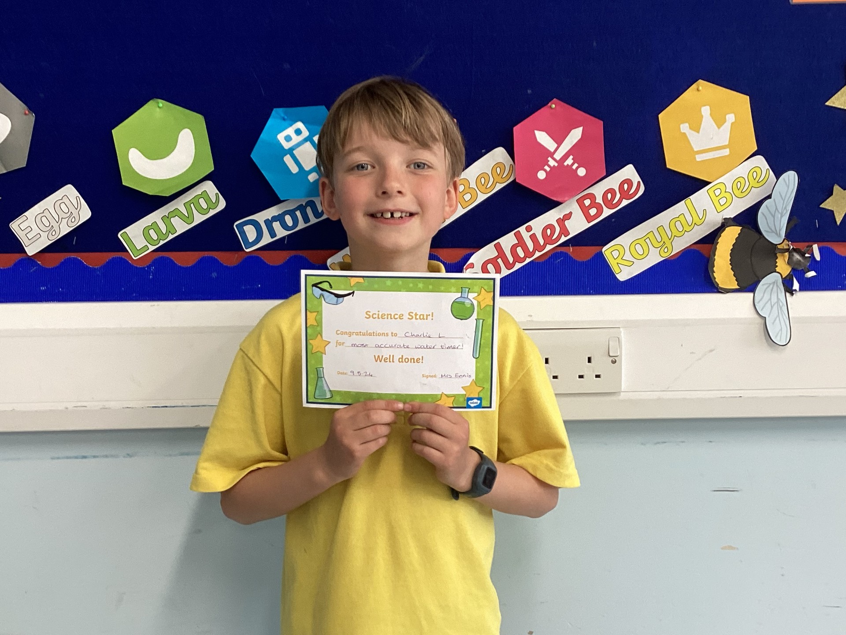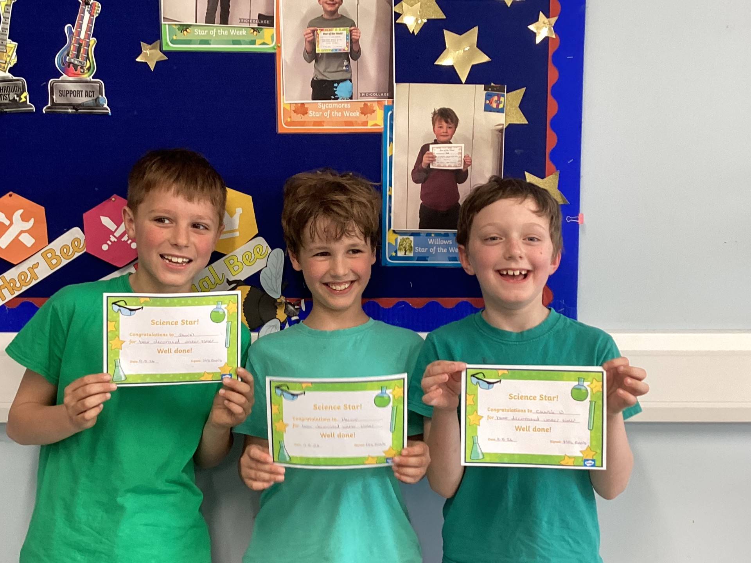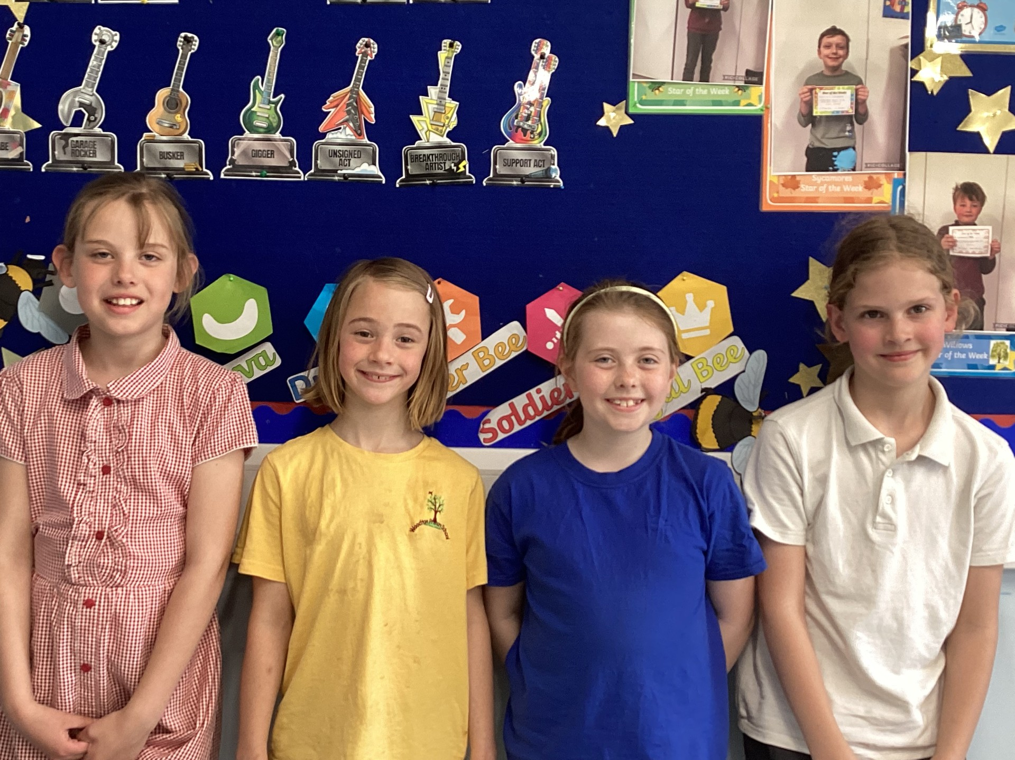

**Long Term Dates for the Diary**

**Monday 13th – Fri 17th May** – Year 6 SAT’s week

**Friday 17th May** – Year 6 Bowling Treat

**Monday 20th May** – Year 4 Tri-Golf Event

**Monday 27th until Friday 31st May** – Half Term

**3rd, 4th, 5th June** – Years 5 & 6 Residential Trip

**Tuesday 11th June** – Tempest Class & Leavers Photos

**Wednesday 12th June** – Willows Banham Zoo Trip (Details to follow)

**Thursday 20th June** – Oaks UEA Athletics s event (Details to follow)

**Wednesday 26th June** – Sycamores Norfolk Show Trip

**Wed 26th & Thurs 27th June** – Year 6 Bungay High Transition Days

**Mon 8th, Tues 9th & Wed 10th July** – Year 6 Hobart High Transition Days

**Thursday 11th July** – Woodton Sports Day

Website – <http://www.ellinghamandwoodton.co.uk/>