

*Issue No: 20 Date: Friday 8th Mar 2024*

*Our Newsletter comes out every Friday with updates about what the children have been up to during the week, information, things to celebrate and important dates for the diary. Please take the time to read through and if you have any questions, please speak to Mrs Taylor in the office.*

**This Week’s Achievements**

**Willows Star of the Week**

**Sycamores Star of the Week**



Millie for showing perseverance in reading and great determination in Forest school.

For being a fantastic mathematician this week.

**Oaks Star of the Week**



**Class Attendance**

Willows – 93.81%

Sycamores – 96.25%

Oaks – 89.71%

CHALLENGE

NURTURE

INSPIRE

CHALLENGE

NURTURE

INSPIRE

**House Points for this week**

Stephen Hawkings – 104

Beatrix Potter – 82

Benjamin Britten – 29

Kelly Holmes – 97

For hard work, creativity and role model behaviour during PE.



Congratulations to

**Phoebe R** for completing **Glass** stage in NumBots this week!



Willows: 1st Ned

2nd Courbon

3rd Lonnie

Sycamores: 1st Daniel

2nd Aria

3rd Finlay

Oaks: 1st Lucas

2nd Charlie T

3rd Illiana



Headliner – Riley

Gigger – Eliza

Rock Legend - Ada



Reminders for Next Week:

**Oaks Class** – PE on Mondays & Wednesdays

**Sycamore Class** – PE on Wednesdays & Thursdays

**Willows Class** – PE Mondays & Fridays

**Fridays Forest School lessons**– Year 2 and Oaks

**Year 4 Cycling Proficiency** – Tuesday 12th March

**Willows Dance Festival** – Wednesday 13th March

**Parents Evening** – Wednesday 13th March

**Parents Science Afternoon** – Thursday 14th March (2pm)

**Science Week**

This year, we will be celebrating Science Week with a fun science challenge for all the children, based around the British Science Week theme of ‘Time’. You are invited to come into school on **Thursday 14th March** at 2pm to take part in the challenge with your child. We hope to see you there!



**Special Meal Change**

The special Easter meal on Wednesday the 27th of March, will now be fish fingers and chips, instead of the breaded chicken burger.



**World Book Day Fun!**

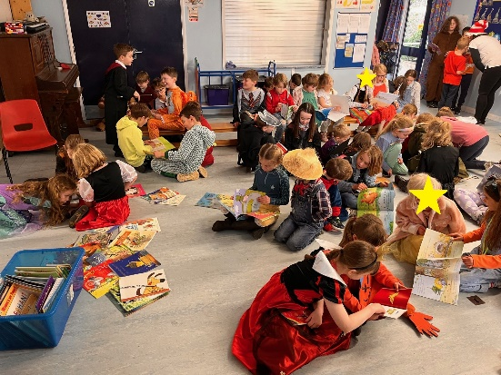

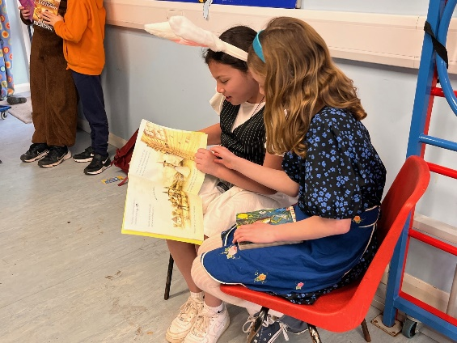**Sharing our stories**

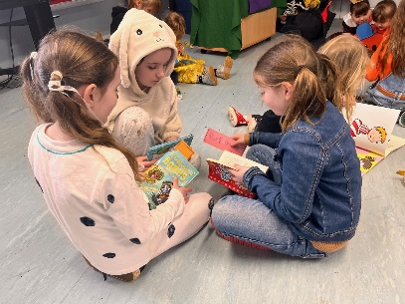

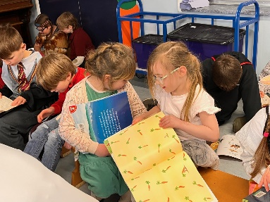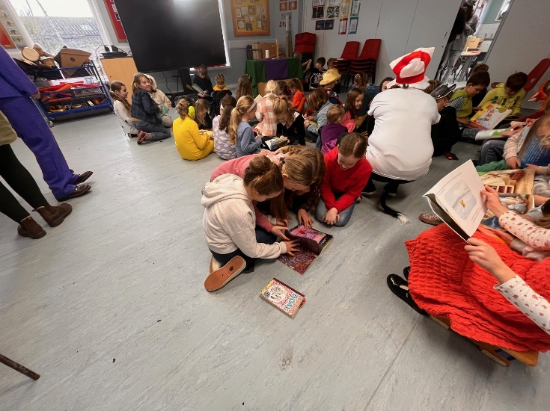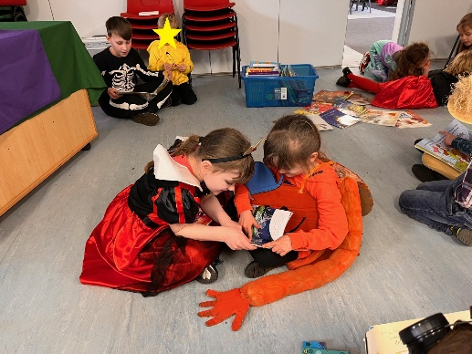

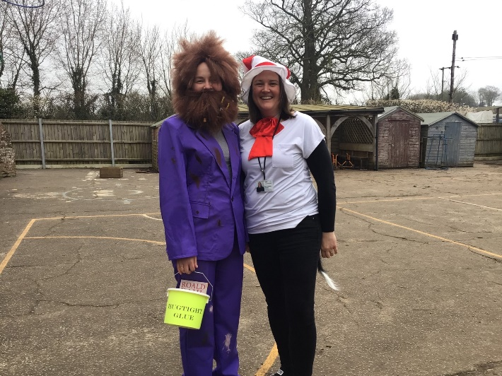**So many book characters!**

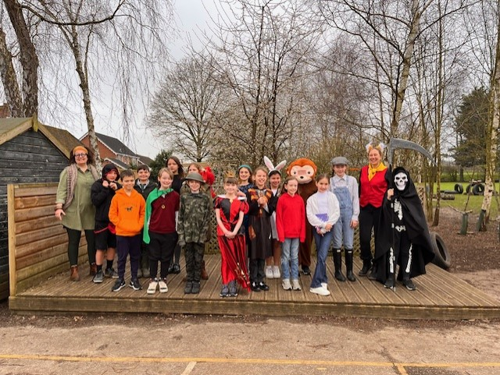

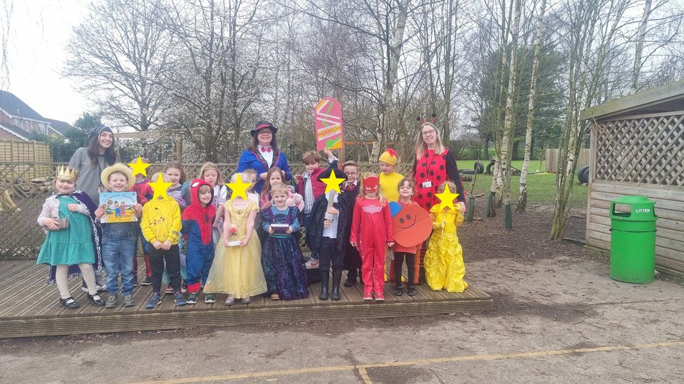



If you’ve enjoyed a treat or saved a few pennies on a loaf of bread at school please consider giving back and helping someone less fortunate than you.

Re:think are launching an Easter campaign and asking for your help.

There will be a collection box in the school office reception up until Wednesday the 27th of March, for any donations of non-food items or Easter treats that you can kindly give to this good cause.

Re:think would like to thank you in advance from the team and families that they support.

**SLOW DOWN!**

Please can we remind everyone, that there is a recommended speed of 20mph passed the school.



**Sports Achievements**

We would really love to know about any sporting achievements that children are doing outside of school. Please feel free to send in or email the school office, pictures and a short description of the achievement, so we can add this to our Sports board.



**Long Term Dates for the Diary**

**11th – 15th March** – Science Week

**Tuesday 12th March** – Year 4 Cycling Proficiency

**Wednesday 13th March** – Parents Evening

**Wednesday 13th March** – Willows Dance Festival

**Thursday 14th March** – Parents invited to join in with the Science Challenge – 2pm

**Wednesday 27th March** – Special Easter Meal – Fish Fingers & Chips

**Wednesday 27th March** – Sycamores Hockey Festival (Details to follow)

**Thursday 28th Mar until Friday 12th Apr** – Easter Holidays

**Monday 15th April** – PTA Non-Uniform Day for an exchange of an Easter Gift

**Friday 19th April** – PTA Springo event

**Thursday 25th April** – Wellbeing Sponsored Walk (Details to follow)

**Monday 6th May** – May Bank Holiday

**Monday 27th until Friday 31st May** – Half Term

Website – <http://www.ellinghamandwoodton.co.uk/>