

*Issue No: 23 Date: Friday 19th Apr 2024*

*Our Newsletter comes out every Friday with updates about what the children have been up to during the week, information, things to celebrate and important dates for the diary. Please take the time to read through and if you have any questions, please speak to Mrs Taylor in the office.*

**This Week’s Achievements**

**Sycamores Star of the Week**



**Willows Star of the Week**



Millie for showing perseverance in reading and great determination in Forest school.

For perseverance and showing resilience when building her Polar climate.

For challenging herself in her learning, both inside and outside of the classroom this week.

**Class Attendance**

Willows – 97.37%

Sycamores – 97.5%

Oaks – 97.06%

CHALLENGE

NURTURE

INSPIRE

CHALLENGE

NURTURE

INSPIRE

**Oaks Star of the Week**

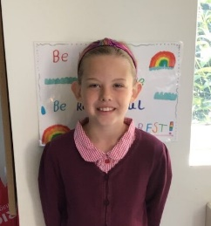

**House Points for this week**

Stephen Hawkings – 162

Beatrix Potter – 146

Benjamin Britten – 115

Kelly Holmes – 116

For an incredible effort in working towards our class target this week – ‘Caught being kind’



Willows: 1st Ned

2nd Lilly-May

3rd Courbon

Sycamores: 1st Finlay

2nd Daniel

3rd Paige

Oaks: 1st Charlie T

2nd Riley

3rd Lucas



Gigger – Courbon

Rock Star - Daniel

Breakthrough Artist - Theo



No NumBot stages completed this week!!!



**Achievements**

Well Done to AdC for being awarded a Blue Peter badge for creating a poster to save the Otters.

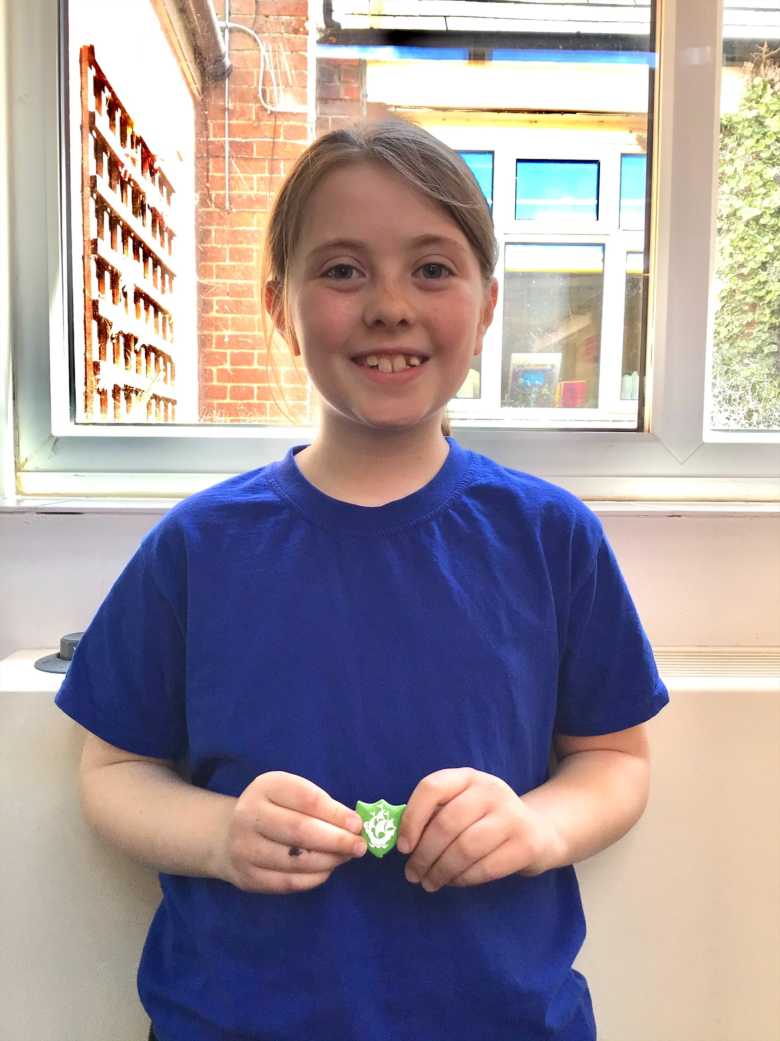

Reminders for This Term:

**Oaks Class** – PE on Mondays & Wednesdays

**Sycamore Class** – PE on Wednesdays & Thursdays

**Willows Class** – PE Mondays & Fridays

**Fridays Forest School lessons**– Sycamores & Reception/Year 1’s

**Wellbeing Sponsored Walk**

Sponsor forms were sent home before the Easter break, for our Wellbeing sponsored walk that is taking place on Thursday the 23rd of April.

The walk is to raise funds for our new project of a Wellbeing Garden, which will be situated next to the school hall. We have made a fantastic start to clearing the area.

Please may we ask that all sponsor forms with money be handed in by Thursday the 23rd of April.

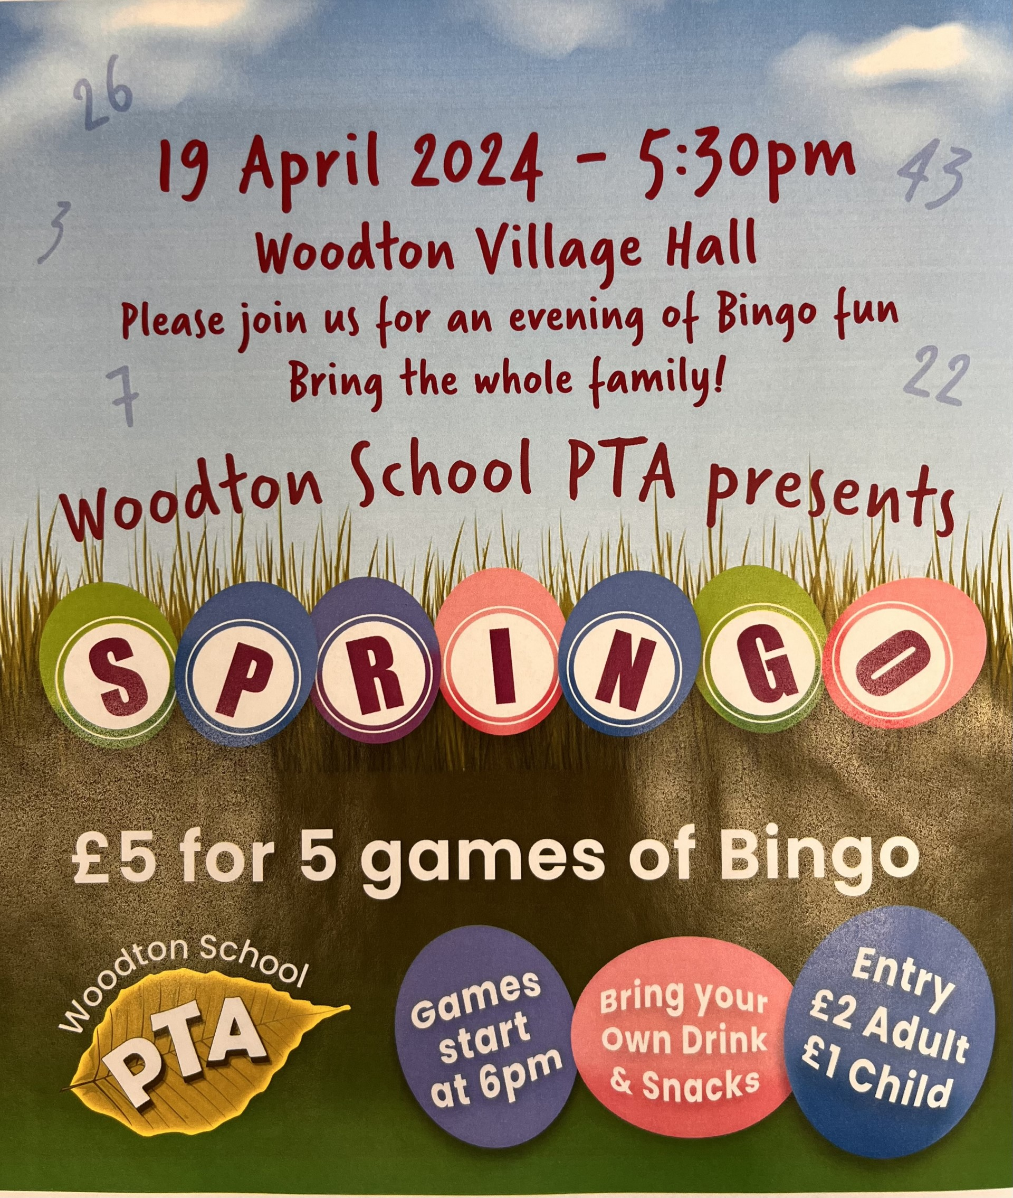

**Long Term Dates for the Diary**

**Friday 19th April** – PTA Springo event

**Tuesday 23rd April** – Year 6 Forensic Science Day

**Thursday 25th April** – Wellbeing Sponsored Walk

**Wednesday 1st May** – KS1 Multi-Skills Event (Details to follow)

**Thursday 2nd May** – KS1 Cricket Festival (Details to follow)

**Monday 6th May** – May Bank Holiday

**Wednesday 8th May** – Year 6 & R Height, Weight, Vision & Hearing

**Mon 13th – Fri 17th May** – Year 6 SAT’s week

**Monday 20th May** – Sycamores Tri-Golf Event (Details to follow)

**Monday 27th until Friday 31st May** – Half Term

**3rd, 4th, 5th June** – Years 5 & 6 Residential Trip

**Tuesday 11th June** – Tempest Class & Leavers Photos

**Wednesday 12th June** – Willows Banham Zoo Trip (Details to follow)

**Wed 26th & Thurs 27th June** – Year 6 Bungay High Transition Days

**Mon 8th, Tues 9th & Wed 10th July** – Year 6 Hobart High Transition Days

**Thursday 11th July** – Woodton Sports Day

Website – <http://www.ellinghamandwoodton.co.uk/>