

*Issue No: 19 Date: Friday 1st Mar 2024*

*Our Newsletter comes out every Friday with updates about what the children have been up to during the week, information, things to celebrate and important dates for the diary. Please take the time to read through and if you have any questions, please speak to Mrs Taylor in the office.*

**This Week’s Achievements**

**Willows Stars of the Week**



**Sycamores Stars of the Week**

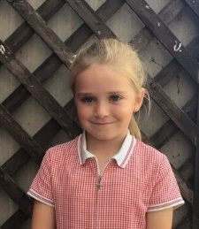

For showing care and demonstrating great art skills this week.

For being focused and accepting challenges set in her Math’s work this week.

CHALLENGE

NURTURE

INSPIRE

CHALLENGE

NURTURE

INSPIRE

**Oaks Stars of the Week**

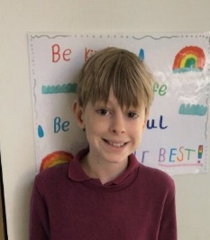

For writing

**Class Attendance**

Willows – 96.41%

Sycamores – 95.88%

Oaks – 94.6%

**House Points for this week**

Stephen Hawkings – 142

Beatrix Potter – 91

Benjamin Britten – 100

Kelly Holmes – 102





Willows: 1st Ned

2nd Jack M M

3rd Courbon

Sycamores: 1st Molly

2nd Ada

3rd Hector

Oaks: 1st Nora

2nd Lucas

3rd Jesse



Busker - Eliza



Congratulations to

**Phoebe R** for completing the **CHROME, Cleo** for completingthe **TIN, Jack D** for completing the **COPPER and Arlo** for completing the **BRASS** stages in NumBots this week!



**Parents Evenings**

Parents evenings will be running on

**Tuesday 5th March**

**Wednesday 13th March**

These will be available to sign up to, in the school office after the half term break.

**Volunteers**

We are looking for volunteers to hear children read.If you have time to spare each week and would be interested in volunteering regularly, please contact the school office for an application form.



**Attendance**

A reminder that school starts at 8:40 and any children arriving after the door shuts at 8:50 (sharp) will be marked as late.



Reminders for Next Term:

**Oaks Class** – PE on Mondays & Wednesdays

**Sycamore Class** – PE on Wednesdays & Thursdays

**Willows Class** – PE Mondays & Fridays

**Fridays Forest School lessons**– Year 2 and Oaks

**Dates for the Diary**

**Monday 19th until Friday 23rd Feb** – Half Term

**Tuesday 5th March** – Year 4 Seatbelt Lesson

**Tuesday 5th March** – Year 4 Cycling Proficiency (Details to follow)

**Tuesday 5th March** – Year 6 Forensic Science Day **POSTPONED**

**Tuesday 5th March** –Parents Evening (Time slots will go out after half term)

**Thursday 7th March** – World Book Day (Details to follow)

**11th – 15th March** – Science Week – Further details to follow

**Tuesday 12th March** – Year 4 Cycling Proficiency (Details to follow)

**Wednesday 13th March** – Parents Evening (Time slots will go out after half term)

**Wednesday 13th March** – Willows Dance Festival (Details to follow)

**Thursday 28th Mar until Friday 12th Apr** – Easter Holidays

**Monday 6th May** – May Bank Holiday

**Monday 27th until Friday 31st May** – Half Term

Website – <http://www.ellinghamandwoodton.co.uk/>