

*Issue No: 21 Date: Friday 15th Mar 2024*

*Our Newsletter comes out every Friday with updates about what the children have been up to during the week, information, things to celebrate and important dates for the diary. Please take the time to read through and if you have any questions, please speak to Mrs Taylor in the office.*

**This Week’s Achievements**

**Sycamores Star of the Week**



**Willows Star of the Week**



Millie for showing perseverance in reading and great determination in Forest school.

For always giving everything 100% and striving for success.

For showing incredible resilience at the school sleepover and keeping smiling despite not being able to sleep.

**Class Attendance**

Willows – 92.54%

Sycamores – 93.75%

Oaks – 94.61%

CHALLENGE

NURTURE

INSPIRE

CHALLENGE

NURTURE

INSPIRE

**Oaks Star of the Week**



**House Points for this week**

Stephen Hawkings – 151

Beatrix Potter – 108

Benjamin Britten – 109

Kelly Holmes – 95

For showing great determination with all of her work.



Willows: 1st Ned

2nd Courbon

3rd Lilly-May

Sycamores: 1st Finlay

2nd Molly

3rd Maisy

Oaks: 1st Charlie T

2nd Leila

3rd Woody



Gigger – Daniel

Garage Rocker - Courbon

Breakthrough Artist - Theo



Congratulations to

**Noah** for completing **Tin, Alannah** for completing **Brass** and **Joel** for completing **Steel** stages in NumBots this week!



Reminders for Next Week:

**Oaks Class** – PE on Mondays & Wednesdays

**Sycamore Class** – PE on Wednesdays & Thursdays

**Willows Class** – PE Mondays & Fridays

**Fridays Forest School lessons**– Year 2 and Oaks

**Special Meal Change**

The special Easter meal on Wednesday the 27th of March, will now be fish fingers and chips, instead of the breaded chicken burger.



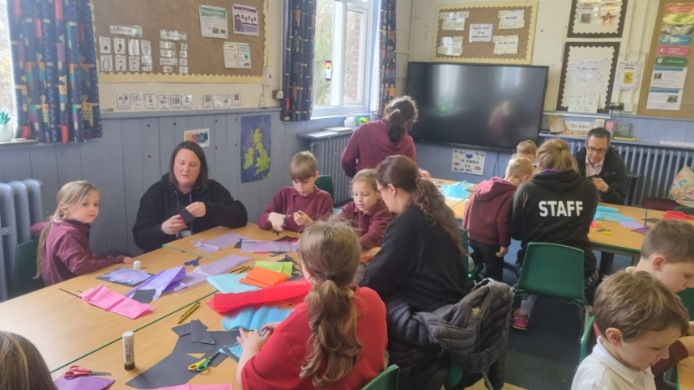**Science Week**

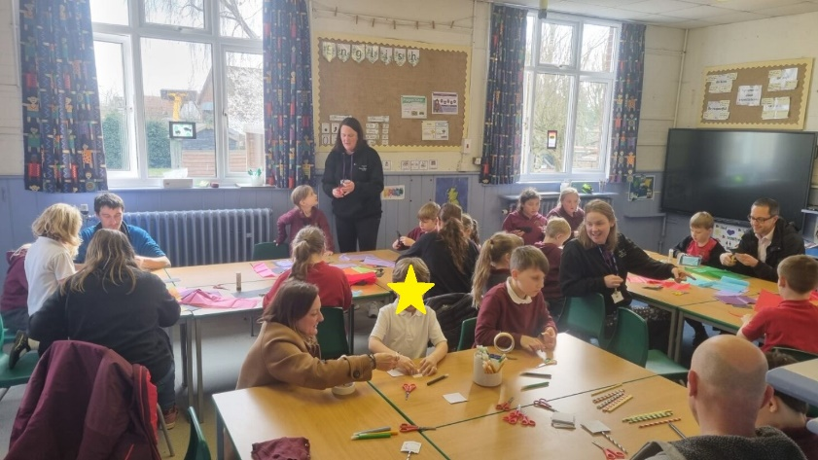

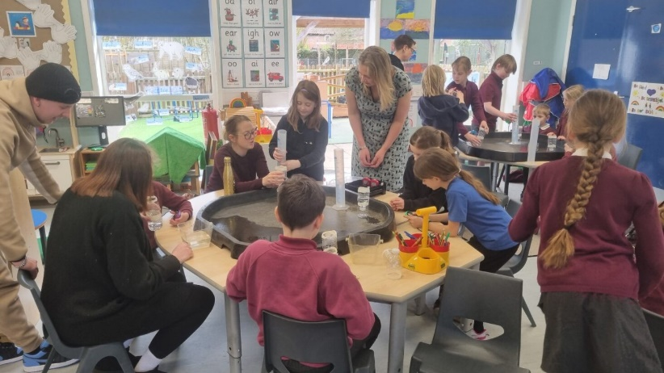Thank you to all the parents that joined us in our special Science afternoon, there was a variety of light catchers, thaumatropes, paper gliders, jumping frogs and water clocks made.

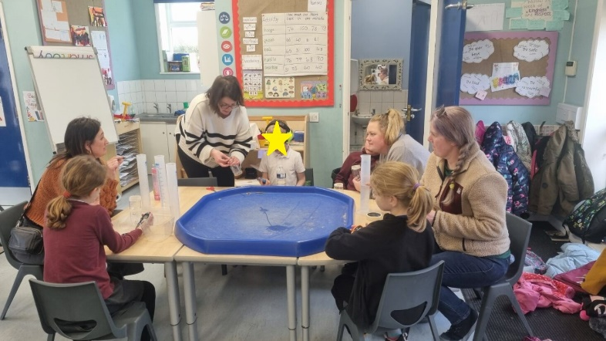

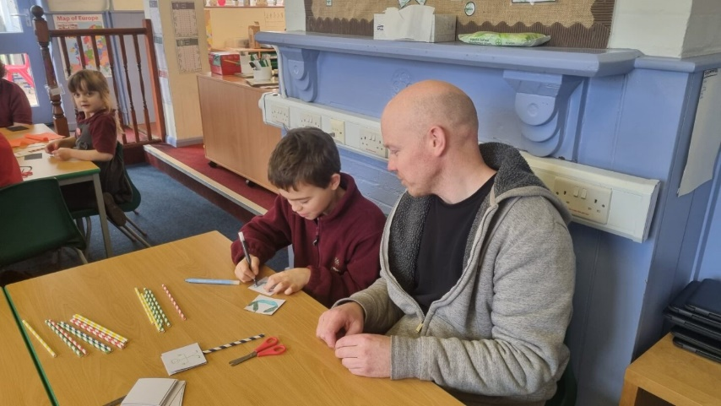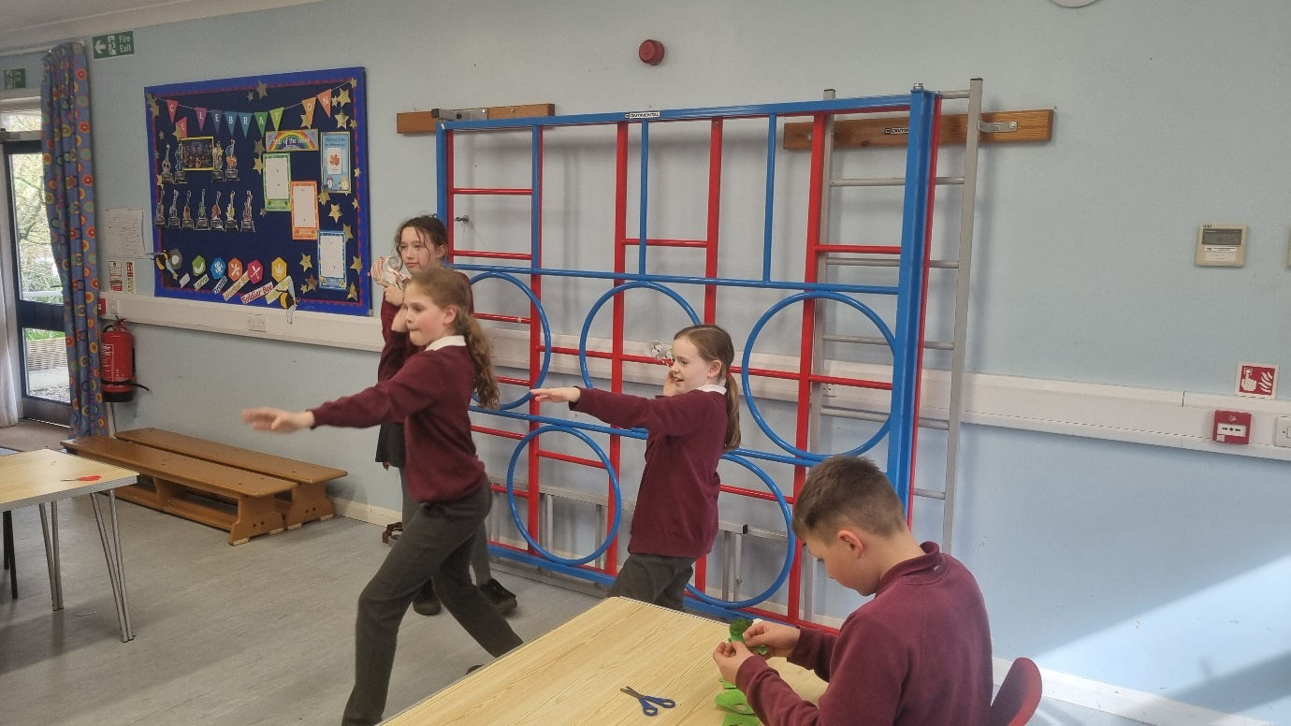



If you’ve enjoyed a treat or saved a few pennies on a loaf of bread at school please consider giving back and helping someone less fortunate than you.

Re:think are launching an Easter campaign and asking for your help.

There will be a collection box in the school office reception up until Wednesday the 27th of March, for any donations of non-food items or Easter treats that you can kindly give to this good cause.

Re:think would like to thank you in advance from the team and families that they support.

**SLOW DOWN!**

Please can we remind everyone, that there is a recommended speed of 20mph passed the school.



**Sports Achievements**

We would really love to know about any sporting achievements that children are doing outside of school. Please feel free to send in or email the school office, pictures and a short description of the achievement, so we can add this to our Sports board.



**Long Term Dates for the Diary**

**Tuesday 26th March** – Sycamores Easter Performance – 6pm

**Wednesday 27th March** – Special Easter Meal – Fish Fingers & Chips

**Wednesday 27th March** – Sycamores Hockey Festival

**Thursday 28th Mar until Friday 12th Apr** – Easter Holidays

**Monday 15th April** – PTA Non-Uniform Day for an exchange of an Easter Gift

**Monday 15th April** – Reception – Benjamin and Bethany Road Safety

**Monday 15th April** – Yr 2 Pedestrian Safety

**Friday 19th April** – PTA Springo event

**Tuesday 23rd April** – Yr 6 Forensic Science Day @ Hobart (Details to follow)

**Monday 22nd April** – Selected Oaks for Netball Tournament @ Hobart (Details to follow)

**Thursday 25th April** – Wellbeing Sponsored Walk (Details to follow)

**Monday 6th May** – May Bank Holiday

**Monday 27th until Friday 31st May** – Half Term

Website – <http://www.ellinghamandwoodton.co.uk/>