

*Issue No: 16 Date: Friday 2nd Feb 2024*

*Our Newsletter comes out every Friday with updates about what the children have been up to during the week, information, things to celebrate and important dates for the diary. Please take the time to read through and if you have any questions, please speak to Mrs Taylor in the office.*

**This Week’s Achievements**

**Willows Stars of the Week**



**Sycamores Stars of the Week**



For wowing us with some excellent descriptive writing.

For completing fantastic Maths work when multiplying by 100.

CHALLENGE

NURTURE

INSPIRE

CHALLENGE

NURTURE

INSPIRE

**Oaks Stars of the Week**



For great work in English and fantastic mentoring in Volleyball.

**Class Attendance**

Willows – 99.12%

Sycamores – 91.67%

Oaks – 92.16%

**House Points for this week**

Stephen Hawkings – 99

Beatrix Potter – 72

Benjamin Britten – 142

Kelly Holmes – 85





Willows: 1st Jack M M

2nd Ned

3rd Courbon

Sycamores: 1st Finlay

2nd Ada

3rd Molly

Oaks: 1st Lucas

2nd Nora

3rd Charlie T



Busker – Theo E & Holly

Unsigned Act – Kendall & Toby

Breakthrough Artist - Maisy

Support Act – Charlie W, Winter & Anya

ROCK HERO - Illiana



Congratulations to

**Jack D & Joel** for completing the **BRASS** and **Joel** for completingthe **Copper** stages in NumBots this week!





**Special Desserts**

Norse are offering special desserts on Tuesday 13th for Pancake Day, and Wednesday 14th for Valentine’s Day. The main meal will stay the same. Please order your child’s school dinner in the normal way and they will automatically receive the special dessert.

**Valentine Maths Morning**

**Wednesday 14th February**

Willows, Sycamores and Oaks would like to invite you all to come and join in with some Valentines themed Math’s with your child.

From 9 till 10am on Wednesday the 14th of February.

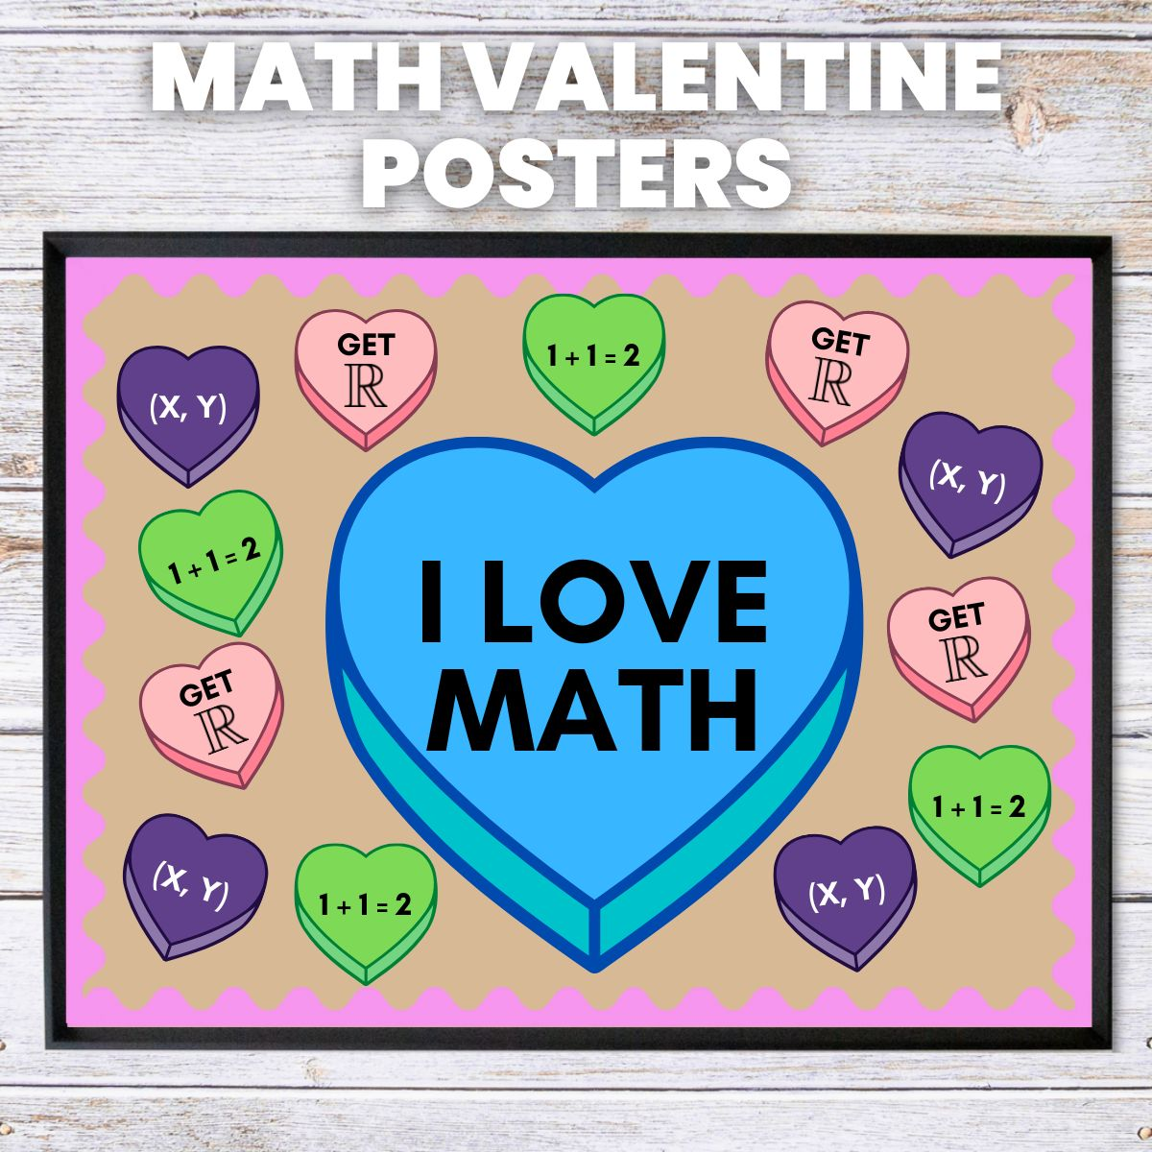

**Attendance**

A reminder that school starts at 8:40 and any children arriving after the door shuts at 8:50 (sharp) will be marked as late.



Reminders:

**Oaks Class** – PE on Mondays & Wednesdays

**Sycamore Class** – PE on Wednesdays & Thursdays

**Willows Class** – Mondays & Wednesdays

**Fridays Forest School lessons**– Reception/Year 1 and Sycamores this term

**Volunteers**

We are looking for volunteers to hear children read.If you have time to spare each week and would be interested in volunteering regularly, please contact the school office for an application form.



**Creative Celebration Evening**

**Friday 9th February**

Thank you to everyone that has responded to the Creative Celebration evening. Tickets will be available to purchase from the school office from Monday.

There is a limit to 2 tickets per family. There may be extras available to purchase, please let the office know if you would like to put your name down for an extra ticket, these will then be distributed from Wednesday.



**Express Yourself – Non-Uniform Day**

**Friday 9th February**

Children’s Mental Health Week 2024 will take place from 5-11 February.

The theme this year is

‘My Voice Matters’.

To support this, we will be holding a non-uniform day, giving children the opportunity to ‘Dress to Express’ on Friday the 9th of February, for a £1 donation. All monies raised will be donated to the charity, Place2Be.



**Dates for the Diary**

**Monday 5th February** – NO SAT’s club for this week only

**Friday 9th February** – Children’s Mental Health Non Uniform Day – Dress to Express £1

**Friday 9th February** - Creative Celebration Evening – 6pm

**Wednesday 14th February** – Valentines Maths Morning 9-10am

**Monday 19th until Friday 23rd Feb** – Half Term

**Monday 5th March** – Year 4 Seatbelt Lesson

**Monday 5th March** – Year 4 Cycling Proficiency (Details to follow)

**Wednesday 6th March** – Year 6 Forensic Science Day

**Thursday 7th March** – World Book Day (Details to follow)

**11th – 15th March** – Science Week – Further details to follow

**Tuesday 12th March** – Year 4 Cycling Proficiency (Details to follow)

**Wednesday 13th March** – Willows Dance Festival (Details to follow)

**Thursday 28th Mar until Friday 12th Apr** – Easter Holidays

**Monday 6th May** – May Bank Holiday

**Monday 27th until Friday 31st May** – Half Term

Website – <http://www.ellinghamandwoodton.co.uk/>