

*Issue No: 24 Date: Friday 26th Apr 2024*

*Our Newsletter comes out every Friday with updates about what the children have been up to during the week, information, things to celebrate and important dates for the diary. Please take the time to read through and if you have any questions, please speak to Mrs Taylor in the office.*

**This Week’s Achievements**

**Willows Star of the Week**



**Sycamores Star of the Week**

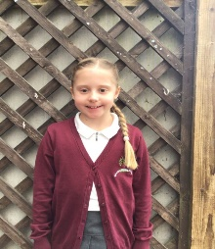

Millie for showing perseverance in reading and great determination in Forest school.

For being an incredible member of Willows.

For using time adverbials correctly in her oral retelling of ‘I swapped my Dad for two goldfish’.

**Class Attendance**

Willows – 98.09%

Sycamores – 96.65%

Oaks – 97.33%

CHALLENGE

NURTURE

INSPIRE

CHALLENGE

NURTURE

INSPIRE

**Oaks Star of the Week**

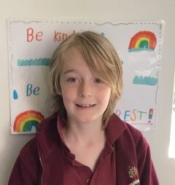

**House Points for this week**

Stephen Hawkings – 116

Beatrix Potter – 104

Benjamin Britten – 97

Kelly Holmes – 71

For fantastic effort in English, especially with handwriting.



Congratulations to

**Dotty** for completing the **Steel** stage in NumBots this week!



Willows: 1st Courbon

Sycamores: 1st Finlay

2nd Maisy

3rd Hector

Oaks: 1st Illiana

2nd Felicity

3rd Phoebe



Gigger – Holly

Unsigned – Eliza

Support Act – Jesse

Headliner - Kendall



**Achievements**

Well Done to FT for being awarded a Blue Peter reading badge for reviewing the book ‘Midnight Gang’.

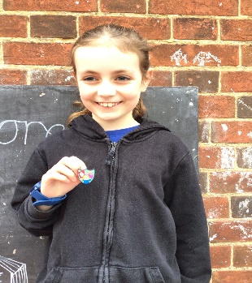

Reminders for This Term:

**Oaks Class** – PE on Mondays & Tuesdays

**Sycamore Class** – PE on Wednesdays & Thursdays

**Willows Class** – PE Mondays & Fridays

**Fridays Forest School lessons**– Sycamores & Reception/Year 1’s

PTA – Springo

The PTA would like to say a big THANK YOU to everyone that supported the Springo event last week, they raised £329!!!



**Wellbeing Sponsored Walk & Yoga**

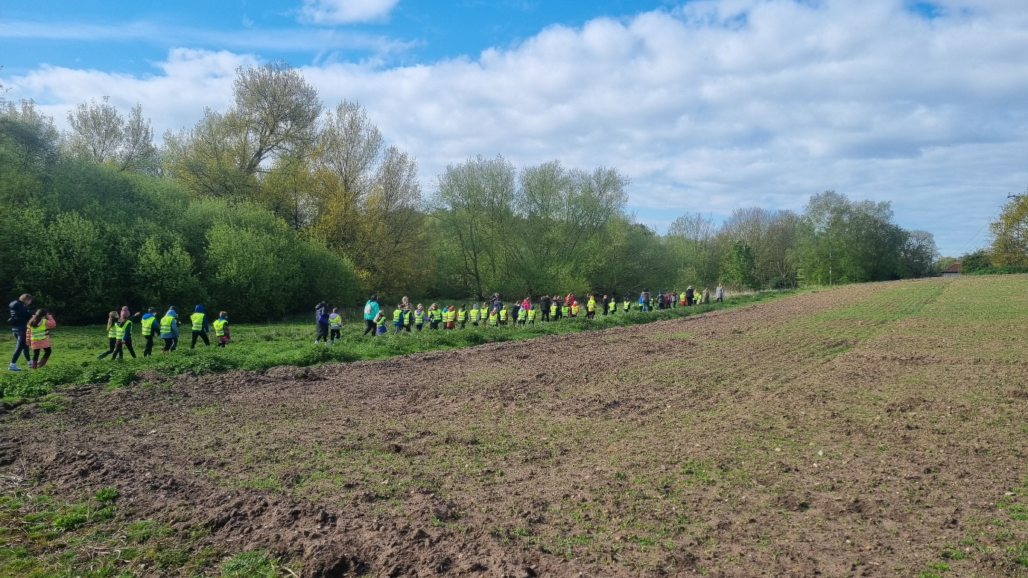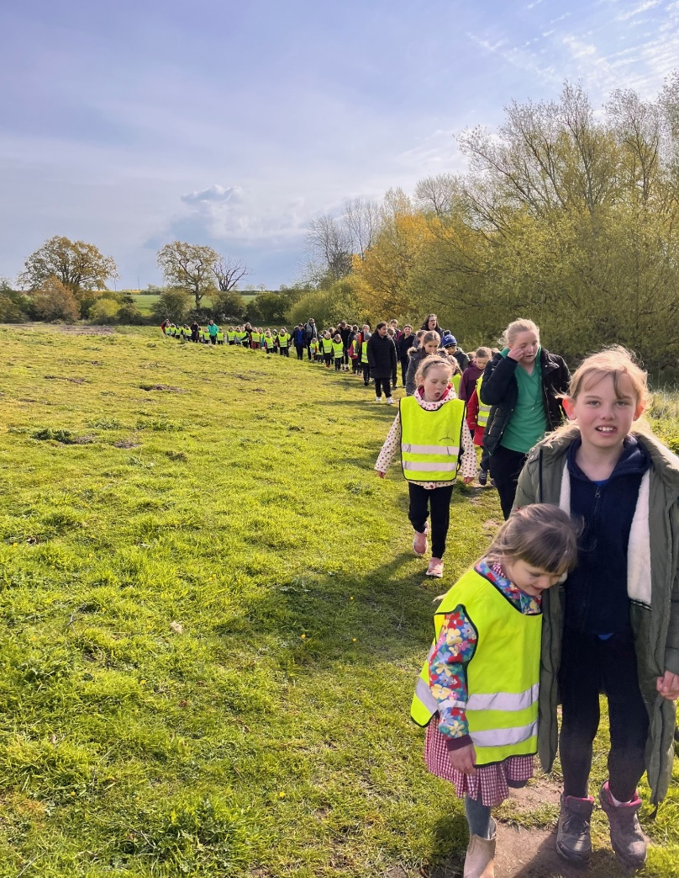

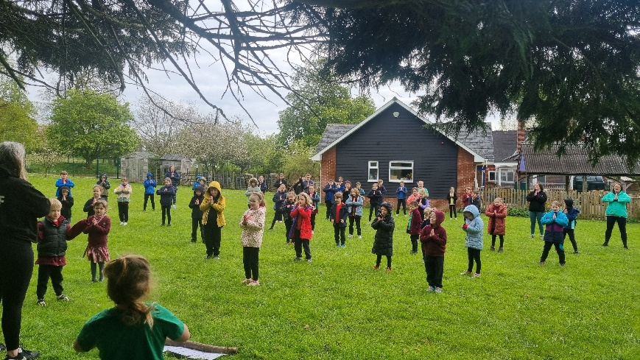

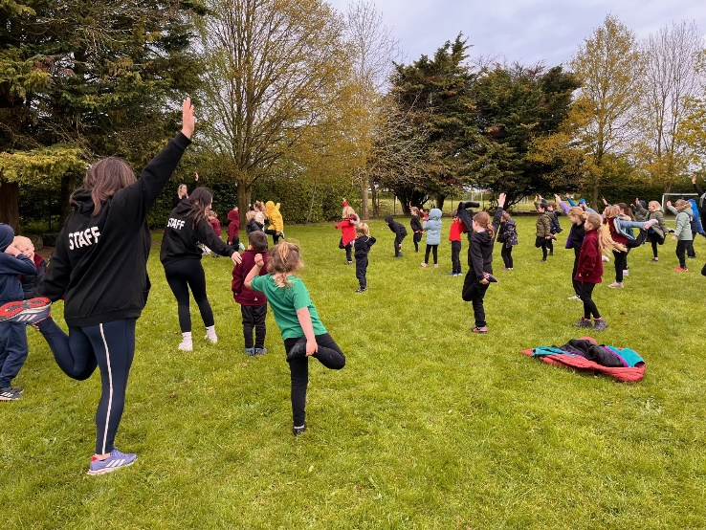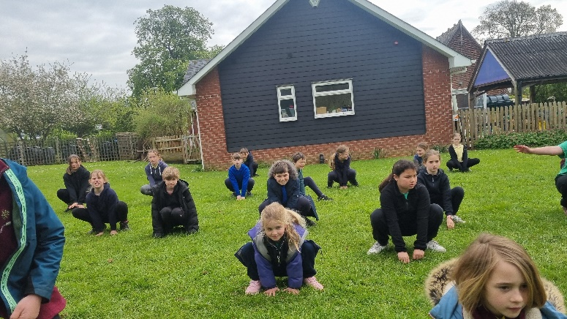

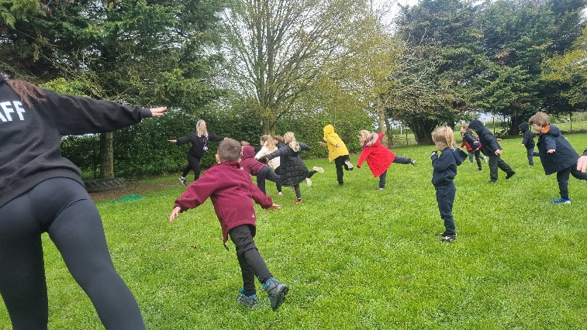

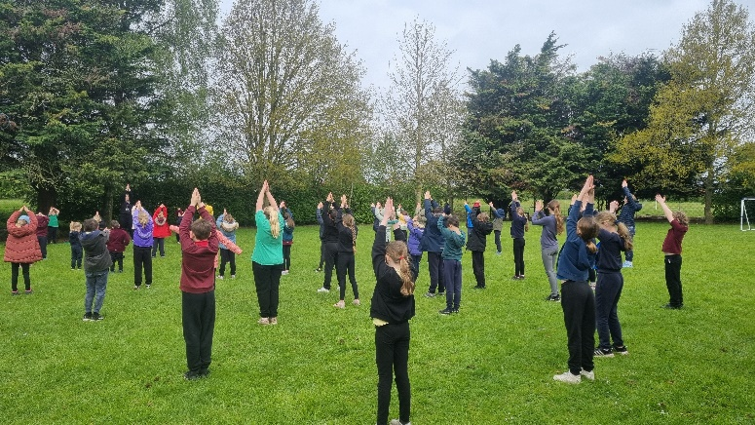

Thank you to everyone that took part in our whole school Wellbeing Sponsored walk and Yoga session. May we ask that all monies raised be brought in by Monday.



**Long Term Dates for the Diary**

**Wednesday 1st May** – KS1 Multi-Skills Event

**Thursday 2nd May** – KS1 Cricket Festival

**Monday 6th May** – May Bank Holiday

**Wednesday 8th May** – Year 6 & R Height, Weight, Vision & Hearing

**Mon 13th – Fri 17th May** – Year 6 SAT’s week

**Monday 20th May** – Sycamores Tri-Golf Event (Details to follow)

**Monday 27th until Friday 31st May** – Half Term

**3rd, 4th, 5th June** – Years 5 & 6 Residential Trip

**Tuesday 11th June** – Tempest Class & Leavers Photos

**Wednesday 12th June** – Willows Banham Zoo Trip (Details to follow)

**Wed 26th & Thurs 27th June** – Year 6 Bungay High Transition Days

**Mon 8th, Tues 9th & Wed 10th July** – Year 6 Hobart High Transition Days

**Thursday 11th July** – Woodton Sports Day

Website – <http://www.ellinghamandwoodton.co.uk/>

**Reminder for Willows Class**

Wed 1st May - Willows Multi-Skills Event (Home Packed Lunch required)

Thurs 2nd May – Willows Cricket Event (Home Packed Lunch required)

Consent for both of these events was due on Wednesday 24th April. Permissions must be given through the pupil asset parent portal, if we do not receive this for your child by Monday 29th April, they will be unable to attend.