

*Issue No: 23 Date: Friday 19th Apr 2024*

*Our Newsletter comes out every Friday with updates about what the children have been up to during the week, information, things to celebrate and important dates for the diary. Please take the time to read through and if you have any questions, please speak to Mrs Taylor in the office.*

**This Week’s Achievements**

**Willows Star of the Week**



**Sycamores Star of the Week**



Millie for showing perseverance in reading and great determination in Forest school.

For settling in really well this week.

For being a fantastic Mathematician this week when working on fractions.

**Class Attendance**

Willows – 97.37%

Sycamores – 97.5%

Oaks – 97.06%

CHALLENGE

NURTURE

INSPIRE

CHALLENGE

NURTURE

INSPIRE

**Oaks Star of the Week**

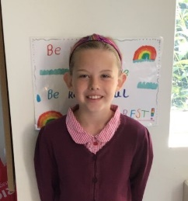

**House Points for this week**

Stephen Hawkings – 162

Beatrix Potter – 146

Benjamin Britten – 115

Kelly Holmes – 116

For an incredible effort in working towards our class target this week – ‘Caught being kind’



Congratulations to

**Phoebe R** for completing the **Tungsten** & **Aluminium, Alannah** for completing the **COPPER and Cleo & Noah** for completing the **BRASS** stages in NumBots this week!



Willows: 1st Courbon

2nd Lilly-May

3rd Ned

Sycamores: 1st Daniel

2nd Hector

3rd Flo

Oaks: 1st Lucas

2nd Illiana

3rd Holly



Garage Rocker - Jesse



**Achievements**

Well Done to AdC for being awarded a Blue Peter badge for creating a poster to save the Otters.

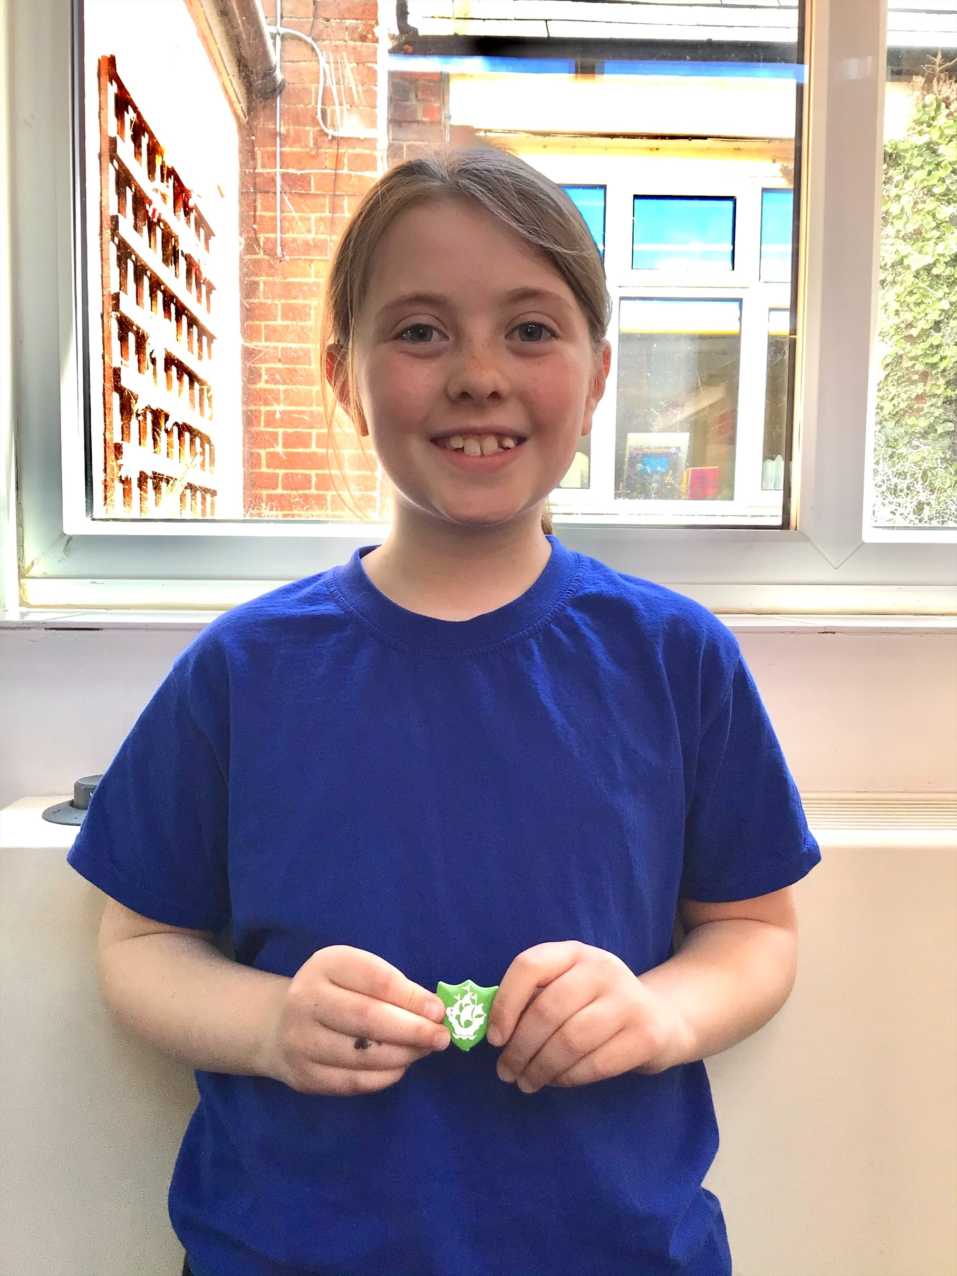

Reminders for This Term:

**Oaks Class** – PE on Mondays & Wednesdays

**Sycamore Class** – PE on Wednesdays & Thursdays

**Willows Class** – PE Mondays & Fridays

**Fridays Forest School lessons**– Sycamores & Reception/Year 1’s

**School Dinners**

All school dinners must be ordered through the pupil asset parent portal by noon on the Friday before.

Dinners can be booked for the whole term if easier.

School dinners must be paid for in advance, either weekly or termly. If payments fall behind, then a home packed lunch will need to be provided until payments are brought up to date.

Norse have increased their meals prices to £2.58.

**Year 6 Forensic Science Day**

**Tuesday 23rd April**

Please remember all year 6 children will require a home packed lunch for this day.

**Wellbeing Sponsored Walk**

Sponsor forms were sent home before the Easter break, for our Wellbeing sponsored walk that is taking place on Thursday the 25th of April.

The walk is to raise funds for our new project the ‘Wellbeing Garden’, which will be situated next to the school hall. We have made a fantastic start with clearing the area, feel free to have a look.

All sponsor forms and any monies raised need to be handed into the school office by Thursday the 25th of April.

Thank you for your continued support!





**Long Term Dates for the Diary**

**Friday 19th April** – PTA Springo event – Eyes down at 6pm

**Tuesday 23rd April** – Year 6 Forensic Science Day

**Thursday 25th April** – Wellbeing Sponsored Walk

**Wednesday 1st May** – KS1 Multi-Skills Event (Details to follow)

**Thursday 2nd May** – KS1 Cricket Festival (Details to follow)

**Monday 6th May** – May Bank Holiday

**Wednesday 8th May** – Year 6 & R Height, Weight, Vision & Hearing

**Mon 13th – Fri 17th May** – Year 6 SAT’s week

**Monday 20th May** – Sycamores Tri-Golf Event (Details to follow)

**Monday 27th until Friday 31st May** – Half Term

**3rd, 4th, 5th June** – Years 5 & 6 Residential Trip

**Tuesday 11th June** – Tempest Class & Leavers Photos

**Wednesday 12th June** – Willows Banham Zoo Trip (Details to follow)

**Wed 26th & Thurs 27th June** – Year 6 Bungay High Transition Days

**Mon 8th, Tues 9th & Wed 10th July** – Year 6 Hobart High Transition Days

**Thursday 11th July** – Woodton Sports Day

Website – <http://www.ellinghamandwoodton.co.uk/>